**A Major Project Report On**

#### **PERSONALIZED FINANCE TRACKER**

#### **Submitted to partial fulfillment of the requirements for the award of the degree of**

### BACHELOR OF TECHNOLOGY

**in**

### COMPUTER SCIENCE AND ENGINEERING (DATA SCIENCE)

**By**

| **SATHYA SANTHOSHI KOKA** | **(21911A6761)** |
| --- | --- |

**Under the Esteemed Guidance of**

## **Dr. R.R.S. RAVI KUMAR Associate Professor**



Department of Computer Science & Engineering(Data Science)

## **VIDYA JYOTHI INSTITUTE OF TECHNOLOGY (An Autonomous Institution)**

**(Approved by AICTE, New Delhi & Affiliated to JNTU, Hyderabad) Aziz Nagar Gate, C.B. Post, Hyderabad-500075**

**2024-25**



**DEPARTMENT OF COMPUTER SCIENCE AND ENGINEERING**

**(DATA SCIENCE)**

# CERTIFICATE

This is to certify that the project report titled “**PERSONALIZED FINANCE TRACKER**” is being submitted by  **SATHYA SANTHOSHI KOKA (21911A6761),**  in partial fulfillment for the award of the Degree of Bachelor of Technology in **Computer Science and Engineering (Data Science),** is a record of bonafide work carried out by them under my guidance and supervision. These results embodied in this project report have not been submitted to any other University or Institute for the award of any degree or diploma.

##### Internal Guide Head of Department

Dr. R R S. Ravi Kumar Dr. KSRK Sarma

Associate Professor Associate Professor & HOD

**External Examiner**

# 

# DECLARATION

##### I SATHYA SANTHOSHI KOKA (21911A6761) Hereby declare that the project entitled, “PERSONALIZED FINANCE TRACKER” submitted for the degree of Bachelor of Technology in Computer Science and Engineering(Data Science) is original and has been done by us and this work is not copied and submitted anywhere for the award of any degree.

|  |
| --- |
|  |
| **Date:** | **SATHYA SANTHOSHI KOKA** | **(21911A6761)** |
| **Place: HYDERABAD** |

# ACKNOWLEDGEMENT

We wish to express our sincere gratitude to the project guide, **Dr.R.R.S. Ravi Kumar, Associate** professor, **Dr.KSRK.Sarma** ,Associate Professor and HOD, Vidya Jyothi Institute of Technology, Hyderabad for her timely cooperation and valuable suggestions while carrying out this work. It is her kindness that made us learn more from her.

We are grateful to **Dr.KSRK.Sarma** ,Associate Professor, and HOD, department of CSE(DS), for her help and support during our academic year.

We wholeheartedly convey our gratitude to Principal **Dr. A.Srujana** for providing the necessary infrastructure to complete this project.

We would thank my parents and all the faculty members who have contributed to our progress through the course to come to this stage.

| **SATHYA SANTHOSHI KOKA** | **(21911A6761)** |
| --- | --- |

# ABSTRACT

# PERSONALIZED FINANCE TRACKER

Personalized Finance Tracker is critical in today’s fast-paced, data-driven world. This project aims to develop a Personalized Finance Tracker powered by machine learning, designed to assist individuals in tracking, categorizing, and optimizing their financial activities. The tracker uses classification algorithms, such as Random Forest, to accurately categorize transactions into predefined categories like groceries, rent, utilities, and entertainment. By analyzing transaction descriptions and user behavior, it provides a clear overview of spending habits, enabling better control over personal budgets.

The finance tracker also incorporates predictive analytics, utilizing time-series forecasting models to predict future spending patterns and cash flow based on historical data. This enables users to anticipate upcoming expenses and make informed financial decisions. Additionally, anomaly detection algorithms are employed to identify irregularities in spending, such as unusually high transactions or potential fraud, helping users maintain financial security.

To enhance user experience, the system is equipped with personalization features that adapt to individual financial habits. By employing machine learning techniques like collaborative filtering, it offers tailored recommendations for budgeting, saving, and expense reduction. Users receive actionable insights such as customized alerts for overspending, savings opportunities, and goal-oriented financial strategies.

The project ensures privacy and security by integrating robust encryption mechanisms for sensitive financial data and adhering to industry-standard security protocols. Furthermore, the solution is scalable, making it suitable for diverse user demographics and varying financial complexities.

This personalized finance tracker bridges the gap between financial literacy and technological innovation. By empowering users with intelligent tools and actionable insights, the system promotes smarter financial decision-making, reduces financial stress, and supports long-term financial well-being.

# INDEX

| **1.INTRODUCTION** | **1** |
| --- | --- |
| **1.1 Existing System** | **2** |
| **1.2 ProposedSystem** | **3** |
| **2. LITERATURE-SURVEY** | **5** |
| **2.1 Feasibility Analysis** | **9** |
| **3. SYSTEM REQUIREMENTS** | **12** |
| **3.1 Hardware Requirements** | **12** |
| **3.2 Software Requirements** | **13** |
| **4.SYSTEM ARCHITECTURE** | **15** |
| **5. SYSTEM DESIGN** | **19** |
| **5.1Architecture Diagram** | **19** |
| **5.2 UML Diagram** | **24** |
| **5.3 Use Case Diagram** | **24** |
| **5.4Activity Diagram** | **25** |
| **5.5Data flow Diagram** | **26** |
| **5.6Component Diagram** | **28** |
| **6.IMPLEMENTATION** | **29** |
| **6.1Code Sample** | **29** |
| **6.2Data set sample** | **34** |
| **6.3Final Output** | **37** |
| **6.4Code Output** | **40** |
| **7. SYSTEM ANALYSIS** | **41** |
| **7.1 Types of Analysis** | **42** |
| **7.2 Modelling** | **43** |
| **8. OUTPUT SCENES** | **46** |
| **8.1 Output** | **46** |
| **8.2 Cleaning The Dataset** | **48** |
| **8.3 Run on Machine Learning Algorithms** | **49** |
| **8.4 Analysis** | **49** |
| **8.5 Factors of Performance Evaluation** | **51** |
| **8.6 Requirement Dataset** | **53** |
| **8.7 Financed Data Large.csv File** | **54** |
|  |  |
| **9. CONCLUSION** | **55** |
| **10. FUTURE ENHANCEMENT** | **56** |
| **11. REFERENCES** | **57** |
|  |  |

|  |  |
| --- | --- |
|  |  |
|  |  |
|  |  |
|  |  |

| **LIST OF FIGURES** | **PGNO** |
| --- | --- |
| **LSTM** | **17** |
| **Random Forest** | **18** |
| **Use Case Diagram** | **23** |
| **Component diagram** | **24** |
| **Activity Diagram** | **25** |
| **Class Diagram** | **26** |
| **Data Flow Diagram** | **27** |
| **Sample Codes** | **32** |
| **Histogram Plot Analysis** | **42** |
| **Box Plot Analysis** | **43** |
| **Flow Chart of Random Forest** | **45** |
| **Output** | **46** |
| **Performance Evaluation** | **52** |
| **Finance Data Large.CSV file** | **54** |

# CHAPTER-1

# INTRODUCTION

* Personal finance refers to the management of an individual's or family's financial activities. This includes budgeting, saving, investing, and planning for retirement. The first step in effective personal finance management is understanding your current financial situation and setting clear, achievable goals. This unit introduces the concept of personal finance, its importance in daily life, and how financial literacy can empower individuals to make informed decisions.
* Setting Financial Goals-Financial goals serve as a roadmap for managing money. They help prioritize spending and encourage disciplined saving and investing. Short-term goals might include saving for a vacation or paying off a credit card, while long-term goals could involve purchasing a home or retiring comfortably. This unit explores the SMART goals framework and provides examples of financial planning over different time horizons.
* Budgeting Basics -A budget is a detailed plan that outlines income and expenses over a specific period, typically monthly. This unit explains different budgeting methods such as zero-based budgeting, the 50/30/20 rule, and envelope budgeting. You'll learn how to categorize expenses, track spending habits, and make adjustments to stay on target.
* People typically utilise a traditional paper system to keep track of their income and expenses in order to trace their expenses. It takes time to set up in this manner. Therefore, there has to be a management system that makes it simple for us to track our daily income and expenses and also enables us to identify records accurately.
* We therefore figured out the best approach to do away with the conventional technique using a digital, portable, simple, and quick manner to record this data with our Expense Tracker. The user can keep track of his expenses and categorise them using graphs and tables, which helps them better understand their spending habits. The users of this app can set monthly caps over particular categories assisting them in avoiding spending too much on those things. Additionally, the app will alert users if they go over their budget or make repeated purchases
* . Our primary goal is to enable customers to achieve Personal Life by enabling them the flexibility to keep track of their costs, examine consumer patterns, and evaluate their future transactions on the account. Therefore, the main goals of creating this intelligent Finance tracker are to give our consumers a better understanding of their spending and encourage savings.
  1. **EXISTING SYSTEMS**

In the current landscape of personal finance management, most systems rely on traditional, rule- based approaches for tracking and categorizing financial data. Applications such as Mint, YNAB, and PocketGuard are widely used by individuals to manage their budgets, monitor expenses, and maintain control over their financial health. However, these systems typically depend on static rules or keyword-based matching to categorize transactions, which often leads to incorrect classifications, especially when users encounter new merchants or unusual spending patterns. Additionally, the predictive capabilities of existing systems are generally limited to simple statistical models, such as calculating averages from past months or using linear trend lines, which are not well-equipped to handle the complexities and irregularities present in real-world personal finance data.

Personalization in such systems is minimal; most users receive generic reports and recommendations that do not deeply reflect their unique financial habits, making it difficult for them to make informed and adaptive financial decisions. Furthermore, anomaly detection is often absent or manual, which can expose users to undetected fraudulent activity or unplanned spending deviations. Overall, existing systems offer static and surface-level support rather than true intelligence or proactive financial guidance.

**1.2 PROPOSED SYSTEMS**

The proposed system aims to overcome these limitations by integrating machine learning techniques, specifically Random Forest algorithms for transaction categorization and Long Short-Term Memory (LSTM) networks for financial forecasting. Unlike the static rule-based models used in conventional applications, the Random Forest classifier will analyze multiple transaction features such as merchant names, transaction descriptions, frequency patterns, and historical user behavior to classify expenses more accurately.

This approach allows the system to adapt to new types of transactions over time and personalize its categorization for individual users. Alongside this, LSTM — a deep learning model designed for time-series prediction — will be utilized to understand the temporal relationships in a user’s financial data, enabling the system to predict future cash flows, spending trends, and potential financial risks more effectively than traditional models. By continuously learning from user interactions and financial history, the proposed system will not only improve accuracy but also deliver tailored recommendations and alerts that reflect the user’s personal lifestyle and financial goals.

Moreover, the intelligent design of the system will allow for automated detection of anomalies, making it capable of flagging unusual or potentially fraudulent transactions in real time. Altogether, this machine learning-powered finance tracker is designed to offer a dynamic, adaptive, and highly personalized financial management experience that goes far beyond what current systems are able to provide.

**Random Forest** for Expense Categorization Instead of static rules, the system will use Random Forest (an ensemble machine learning algorithm) to classify transactions based on:

Merchant names

Transaction descriptions

Amount patterns

Time and frequency

User historical behavior

This makes the categorization more accurate, especially for new or ambiguous transaction types.

**LSTM for Financial Forecasting**

Long Short-Term Memory (LSTM) networks are specialized for time-series data, making them perfect for:

Predicting future spending trends

Cash flow forecasting

Budget recommendations based on historical financial data

LSTM can capture the temporal dependencies in personal income and spending patterns, which traditional models miss.

**Personalization Engine**

The combination of Random Forest and LSTM enables the system to:

Adapt to individual financial habits Suggest personalized saving goals and budget adjustments Detect anomalies (fraud or unexpected expenses) intelligently.Improved User Experience Compared to existing static systems, this model will:

Continuously learn from user feedback and corrections

Offer real-time predictions and suggestions

Present insights tailored to each user's lifestyle, rather than generic reports.

# 

# CHAPTER-2

# LITERATURE SURVEY

* Personal finance management has increasingly become a focus area in both academic research and commercial software development. With the rise of digital banking and cashless transactions, individuals generate large amounts of financial data, which offer both opportunities and challenges for effective analysis. Traditional rule-based finance tracking tools have served a functional role, but lack flexibility and intelligence when it comes to personalization and prediction. The integration of Machine Learning (ML) and Deep Learning (DL) models, such as Random Forest and Long Short-Term Memory (LSTM) networks, introduces the potential for smarter systems capable of learning, adapting, and forecasting financial behaviors with a higher degree of accuracy. This literature survey reviews key studies and technological advancements related to personal finance tracking systems, categorization algorithms, and predictive financial modeling using these techniques.
* . Personal Finance Management Systems: A Background Early personal finance management systems were primarily designed to assist users in tracking income and expenses manually. Tools like Quicken and Microsoft Money, introduced in the late 20th century, pioneered this domain. These systems typically used basic logic to segregate transactions, which required extensive user input to maintain accuracy. More recent platforms such as Mint and YNAB transitioned toward automated transaction categorization by employing keyword matching, regular expressions, and merchant identification databases. While these advances reduced the manual workload, they also highlighted the limitations of hardcoded rules in handling evolving financial behavior and new merchant ecosystems.
* Research by Khandani et al. (2010) introduced the idea of using machine learning models for consumer credit risk analysis, which can be extended to financial behavior prediction. Their work demonstrated the importance of non-linear models in understanding financial patterns. Similar approaches laid the groundwork for transitioning finance tracking from static rule-based models to intelligent systems capable of pattern recognition and adaptive learning.
* Random Forest for Financial Data Classification Random Forest, a robust ensemble learning method proposed by Breiman (2001), is widely used for classification tasks, including financial applications. This model combines the predictions of multiple decision trees to enhance classification performance and reduce the risk of overfitting. Financial data is often high-dimensional and noisy, characteristics that make Random Forest a suitable choice for transaction categorization.
* A study by Lessmann et al. (2015) compared machine learning algorithms for credit scoring and found Random Forest to be superior in terms of prediction accuracy and robustness against unbalanced data. Applying Random Forest to personal finance tracking involves feeding the model transaction attributes such as transaction amount, timestamp, merchant name, and textual description to predict categories like groceries, utilities, entertainment, or travel. Unlike static rule-based systems, Random Forest adapts to complex patterns and can generalize well to new unseen transactions, offering improved accuracy and personalization.
* LSTM Networks for Financial Forecasting Long Short-Term Memory (LSTM) networks, introduced by Hochreiter and Schmidhuber (1997), are a type of recurrent neural network (RNN) capable of learning long-term dependencies in sequential data. Financial data is inherently temporal, with patterns linked to pay cycles, seasonal changes, and irregular spending behaviors, which makes LSTM an ideal choice for predictive tasks in this domain.
* A number of studies have validated the effectiveness of LSTM in forecasting financial time series. For instance, Fischer and Krauss (2018) used LSTM to predict stock price movements, outperforming traditional linear models and feedforward neural networks. Similarly, Bao et al. (2017) proposed a deep learning framework combining wavelet transforms and LSTM to forecast stock prices, illustrating how LSTM can capture both local and global trends.
* When applied to personal finance tracking, LSTM can predict future expenses, detect deviations from budget expectations, and even suggest optimal saving strategies based on historical trends. This predictive capability allows for proactive financial planning and enhances the overall decision-making experience for users.
* Hybrid Approaches and Personalization in Finance Tracking The concept of combining different machine learning algorithms for improved prediction and classification has gained momentum in recent years. Hybrid models leveraging the strengths of both Random Forest and LSTM have been proposed for various applications, including fraud detection, credit scoring, and sales forecasting.
* In the context of personal finance management, hybrid models can be designed to handle both the categorization and prediction tasks in an integrated pipeline. The Random Forest model efficiently categorizes raw transaction data, while the LSTM model handles the sequential aspects of financial forecasting. Such integration ensures not only accurate past-data interpretation but also reliable future-data prediction, offering a comprehensive solution for personal financial planning.
* Studies such as those by Patel et al. (2015) have demonstrated that combining multiple machine learning techniques improves the reliability of financial systems in terms of both accuracy and adaptability. Moreover, personalized models trained on user-specific data, as explored in adaptive recommendation systems (Zhang et al., 2019), highlight the potential for tailoring financial advice and predictions to individual user behavior.
* Anomaly Detection and User Behavior Analysis Another critical aspect of a personalized finance tracker is anomaly detection. Financial anomalies, including fraudulent transactions or unplanned high expenses, can significantly disrupt personal budgeting. Machine learning techniques, including ensemble methods like Random Forest and sequence-based methods like LSTM, have proven effective in identifying these outliers.
* Chandola et al. (2009) provided a comprehensive survey on anomaly detection techniques, which emphasized the importance of combining unsupervised and supervised models for real-world anomaly detection tasks. In finance, Random Forest can identify outlier transactions based on historical classification, while LSTM can flag unexpected sequence patterns in spending, providing an additional layer of security and intelligence to the finance tracker.
* The existing literature strongly supports the application of Random Forest and LSTM in building a personalized finance tracking system. Random Forest's strength in handling complex classification tasks, combined with LSTM's powerful capabilities in sequential prediction, creates a highly adaptive framework for modern financial management solutions. Together, these models offer not only automation and improved accuracy but also deeper personalization, enabling users to make informed and proactive financial decisions. The growing interest in hybrid machine learning systems within the financial sector further validates the direction of this proposed work, highlighting its potential for significant real-world impact.

**2.1 FEASIBILITY ANALYSIS**

Before proceeding with the design and development of the proposed system, it is important to evaluate its feasibility from multiple perspectives. A thorough feasibility analysis ensures that the project is not only technically achievable but also practical, cost-effective, and beneficial to its intended users. The following analysis examines the proposed system based on technical, economic, operational, legal, and schedule feasibility.

**# Technical Feasibility**

The proposed system is technically feasible as it relies on well-established machine learning and deep learning techniques that have been proven effective in various financial data analysis tasks. The system employs a Random Forest classifier for transaction categorization and an LSTM network for future financial prediction, both of which are supported by modern software libraries such as Python’s Scikit-learn, TensorFlow, and Keras. The system design also makes use of structured transactional data, which is readily available through banking APIs or manual imports. With the availability of cloud computing platforms like Google Colab, AWS, and Microsoft Azure, the computational requirements for model training and deployment are both manageable and scalable. Therefore, there are no significant technological barriers to implementing the proposed system.

**# Economic Feasibility**

The economic feasibility of the project is strong, as the development costmainly consists of time invested by developers and data scientists, as well as cloud resources for training the models. Since many machine learning and deep learning libraries are open-source, the software licensing costs are minimal. In addition, the growing demand for personalized financial tools provides a strong potential for market adoption, making the project commercially viable. Once deployed, the system is expected to reduce financial planning errors and improve user satisfaction, offering long-term value for both end users and developers. Compared to the potential benefits, the development and maintenance costs are reasonable, suggesting the project is economically justified.

**# Operational Feasibility**

Operationally, the system is highly feasible as it is designed to integrate smoothly into the daily routines of end users through a user-friendly web or mobile application. Once users link their transaction history, the system will automatically categorize expenses, predict future spending, and highlight unusual patterns, minimizing manual input. Personalized recommendations, alerts, and visual reports will make it easier for users to control their finances without requiring them to have technical knowledge of machine learning or data analysis. The learning component of the system ensures that it continuously improves with user feedback, making it more accurate and reliable over time.

**# Legal Feasibility**

As the proposed system will handle sensitive financial data, legal and ethical considerations are critical. The system must comply with data protection laws, such as the General Data Protection Regulation (GDPR) for European users and the California Consumer Privacy Act (CCPA) for U.S. users. To ensure legal compliance, the system will implement secure authentication, data encryption, anonymization, and clear user consent mechanisms. In addition, the system will avoid using data for unauthorized purposes and ensure transparency in how predictions and classifications are made. If these protocols are properly designed and enforced, the system will be legally feasible and ethically sound.

**# Schedule Feasibility**

Given the clearly defined scope and modular design of the system, the project is also considered schedule-feasible. Model development for Random Forest classification and LSTM prediction can proceed in parallel, with initial versions being trained on existing financial datasets. Once the models are stable, system integration and user interface design can be developed concurrently. Using agile methodologies, the system could be delivered in iterative phases, allowing for testing and feedback from early users before full deployment. Considering modern development tools and cloud resources, the estimated time for completion is realistic and achievable.

# CHAPTER-3

# SYSTEM REQUIREMENTS

# 

# Personalised Finance Tracker, the system requires a combination of reliable hardware and efficient software environments. Below are the detailed hardware and software requirements:

# 3.1 Hardware Requirements For Development & Model Training:

# Processor: Intel i5 / i7 (8th Gen or later) or AMD Ryzen 5 / 7 equivalent — multi-core CPU recommended for faster data preprocessing.

# RAM: Minimum 16 GB (32 GB recommended) — to handle large datasets and machine learning model training smoothly.

# GPU: NVIDIA GPU with CUDA support (e.g., GTX 1660 Super / RTX 3060 or higher) for LSTM training acceleration and deep learning tasks.

# Storage: Minimum 512 GB SSD (1 TB recommended) — for efficient data handling, fast read/write speeds, and model storage.

# Network: Stable internet connection (for downloading datasets, libraries, and integrating APIs).

# For Deployment (User Side):

# Processor: Intel i3 / i5 or equivalent for client-side web or app use.

# **RAM**: 4 GB or more (8 GB recommended for smooth browsing/app use).

# Storage: Sufficient space for local storage of transaction summaries and visualizations (100 MB minimum, more for caching or offline use).

# Network: Active internet connection for real-time financial data sync and cloud-based prediction services.

# **3.2 Software Requirements**

# Development Environment:

# Operating System: Windows 10 / 11, Ubuntu Linux (20.04 or later), or macOS Monterey / later.

# Programming Language:

# Python 3.9 or later — for core machine learning logic.

# Machine Learning & Deep Learning Libraries:

# Scikit-learn (for Random Forest implementation).

# TensorFlow or PyTorch (for LSTM model development).

# Pandas and NumPy (for data manipulation and numerical computing).

# Database:

# SQLite, MySQL, or PostgreSQL (for storing user transaction records and feedback for model retraining).

# Visualization Libraries:

# Matplotlib, Plotly, or Seaborn (for rendering financial trends and prediction charts).

# Version Control:

# Git / GitHub or GitLab (for source code collaboration and versioning).

# Deployment & Integration Tools:

# Cloud Services: Google Cloud,Gardio, AWS, or Microsoft Azure — for model hosting and API deployment (if the model is cloud-based).

# Web Frameworks / Front-end:

# React.js, Angular, or Vue.js (for the web dashboard). Flask or Django (for backend APIs connecting the ML models to the web or mobile interface).

# CHAPTER-4

# SYSTEM ARCHITECTURE

### The system architecture for the proposed Personalised Finance Tracker is designed as a modular and layered framework that efficiently manages both the categorization and forecasting of personal financial transactions. The architecture ensures a seamless flow of data from raw transaction inputs to insightful, user-friendly outputs, while maintaining high performance and data security throughout the process. The architecture is built to handle a variety of data sources, apply machine learning models for intelligent decision-making, and present the results in an intuitive visual format for the user.

### At the core of the system is the Data Collection Layer, which is responsible for gathering transactional data from multiple financial sources. This could include direct integration with banking APIs using secure protocols, or manual data uploads by users in the form of CSV or Excel files. The raw data usually contains transaction identifiers, timestamps, descriptions, amounts, and any initial user-provided categorization if available. The goal at this stage is to centralize all transaction data and prepare it for processing.

### Once the raw data is collected, it passes through the Data Preprocessing and Storage Layer. Here, the system performs data cleaning operations such as removing duplicates, handling missing values, normalizing inconsistent formats, and converting text-based transaction descriptions into usable features through tokenization and encoding. The processed data is stored in a structured format using a relational database system like MySQL or PostgreSQL, ensuring that it can be retrieved efficiently both for training models and generating reports.

### The most critical part of the architecture is the Machine Learning and Prediction Layer, which consists of two specialized models: a Random Forest classifier and an LSTM-based time-series prediction model. The Random Forest classifier is responsible for automatically categorizing new transactions based on historical patterns and the available attributes of each transaction. This eliminates the need for hard-coded rules and allows the system to adapt to diverse spending behaviors. The LSTM model, on the other hand, focuses on predicting future financial behavior by analyzing sequences of past transactions. This model helps forecast monthly expenses, detect spending spikes, and suggest personalized budgeting strategies, providing the user with foresight into their financial patterns.

### Above this is the Business Logic Layer, which serves as the intermediary between the prediction models and the user interface. It is responsible for managing the flow of information, handling user feedback, and applying rules for anomaly detection and alert generation. Whenever the machine learning models classify new transactions or predict future spending, this layer prepares the output for the front-end in a user-friendly format and ensures that the system responds dynamically to user interactions and model updates.

### Finally, the User Interface Layer is where users interact with the system through either a web application or a mobile app. The front-end application displays categorized transactions, visualizes future predictions in the form of graphs and charts, and notifies users about anomalies such as unusual spending patterns. The design focuses on being simple, interactive, and informative, enabling users to make better financial decisions without requiring in-depth technical knowledge.

### Throughout the system, security is maintained as a priority, with encryption applied both at the storage and transmission stages. Additionally, industry-standard authentication and authorization techniques like OAuth 2.0 are integrated to safeguard user identity and sensitive financial data. The entire architecture is built to be scalable and cloud-compatible, meaning the system can evolve to handle larger volumes of data and more complex models as user needs grow. This structure allows for smooth updates, easy integration of new features,

### and the addition of more advanced analytical modules in the future.

### Screenshot 2025-04-16 221342

### Screenshot 2025-04-16 221621

# CHAPTER-5

# SYSTEM DESIGN

### ARCHITECTURE DIAGRAM

The system design for the Personalised Finance Tracker aims to create a smooth flow from raw financial transaction data to meaningful insights for the user. The core of the design revolves around the collection, processing, classification, prediction, and visualization of user transaction data, making it both user-friendly and highly intelligent. The design follows a modular approach to ensure maintainability, scalability, and efficiency.

This layered design ensures the system can continuously improve its accuracy as more transaction data is processed and users interact with the output, especially through feedback mechanism

* + - **Data Collection Module**

The data collection module is the entry point for all user transactions. It is designed to interface with various financial data sources such as:

Bank APIs (e.g., Plaid, Yodlee, Open Banking) that automatically fetch user transaction data.

Manual uploads of CSV or Excel files for users who prefer not to connect their bank accounts directly.

This module ensures that all transactions (including transaction ID, amount, date, merchant, and description) are captured and sent to the next processing layer for analysis. The module is designed to be flexible, supporting both real-time data collection (via APIs) and batch processing (via file uploads).

* + - **Data Preprocessing and Transformation Module**

Once the raw transaction data is gathered, it enters the Data Preprocessing Module, which is responsible for transforming this data into a format suitable for machine learning analysis. This module handles tasks such as:

**Data Cleaning**: Removing duplicates, handling missing values, and correcting data inconsistencies.

**Feature Extraction**: Transforming merchant names, descriptions, and transaction amounts into structured features. For example, text descriptions might be tokenized or encoded into numerical values for machine learning models to process.

**Data Normalization**: Ensuring consistency in data formats, such as converting all monetary values to a single currency and normalizing amounts where necessary.

After the data has been preprocessed, it is stored in a Database Management System (DBMS) such as MySQL or PostgreSQL, where it is organized and can be easily accessed for future model training and user interactions.

* + - **Machine Learning and Prediction Module**

This module is at the heart of the system, where Random Forest and LSTM (Long Short-Term Memory) models are deployed for two key functions:

**Random Forest for Transaction Categorization:** Random Forest is an ensemble learning model that classifies transactions into predefined categories (e.g., Food, Rent, Utilities). It does this by building multiple decision trees based on the historical transaction data. Each tree in the forest “votes” on a category, and the most frequent category is chosen as the prediction. This method is robust to overfitting and adapts to diverse financial data.

**LSTM for Financial Forecasting:** LSTM is a type of Recurrent Neural Network (RNN) that is well-suited for time-series forecasting. The LSTM model in this system predicts future spending trends by analyzing sequences of past transactions. This helps users project their monthly budget, track future expenses, and spot irregularities in their spending patterns.The predictions from both models are integrated and then passed onto the business logic layer

* + - **Business Logic Layer**

The Business Logic Layer serves as the central controller that manages all operations between the backend models (Random Forest and LSTM) and the frontend user interface. Its core responsibilities include:

**Triggering Predictions:** Based on new data inputs, it decides when to invoke the machine learning models (e.g., after a user uploads new transactions or at scheduled intervals).

**Handling User Feedback**: This layer receives user corrections to transaction categorizations (e.g., if a food purchase was mistakenly categorized as an entertainment expense) and uses that feedback to retrain the models, improving their accuracy over time.

**Anomaly Detection:** The business logic layer checks for unusual spending patterns that could indicate fraud or errors and sends notifications to users accordingly.

**Data Aggregation:** The processed transaction data is aggregated into user-friendly reports and visualizations, such as monthly expenditure summaries, predicted future spending, and alerts for overspending in certain categories.

* + - **User Interface Layer**

The User Interface Layer is the frontend of the system, where users interact with the tracker. The interface can be either a web-based dashboard or a mobile app. The UI displays a variety of financial data visualizations, including:

**Categorized Transactions:** Showing how each transaction has been categorized by the system.

**Predicted Spending:** Visualizations that show the predicted future financial behavior (e.g., upcoming monthly spending by category).

**Budget and Alerts**: Providing personalized recommendations and real-time alerts if spending exceeds certain thresholds.

#### This layer is built to be intuitive, responsive, and informative, ensuring that users can make informed decisions without needing to understand the underlying machine learning processes.

### 

### 5.2 USE CASE DIAGRAM:

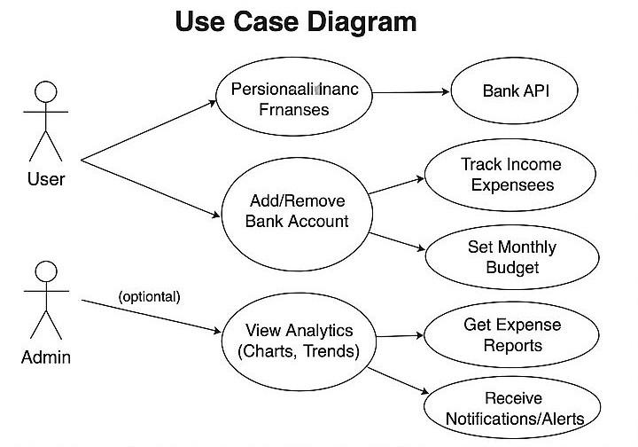

**Figure. 5.2: Use Case Diagram**

The above use case diagram represents the actors and the process in the application.

### 5.3 COMPONENT DIAGRAM:

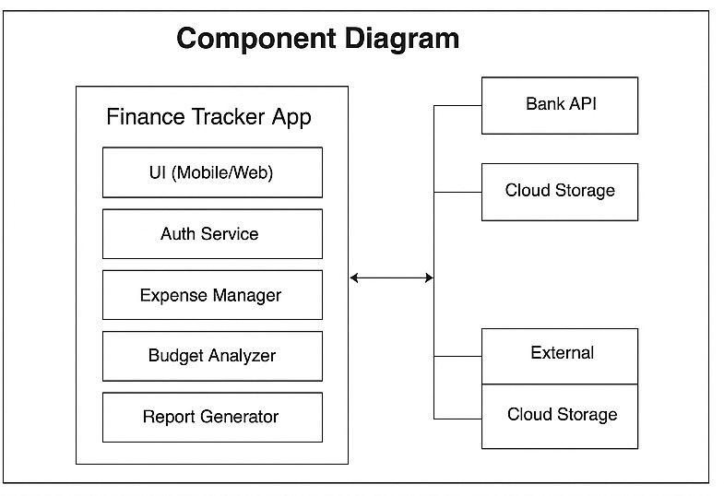

**Figure. 5.2: Component diagram**

The above component diagram describes the organization and wiring of the physical components in a system. It contains user, Dataset, Data Preprocessing as the main components and it shows the relationship between testing set , training set and performance evaluation components.

### 

### 5.3 ACTIVITY DIAGRAM

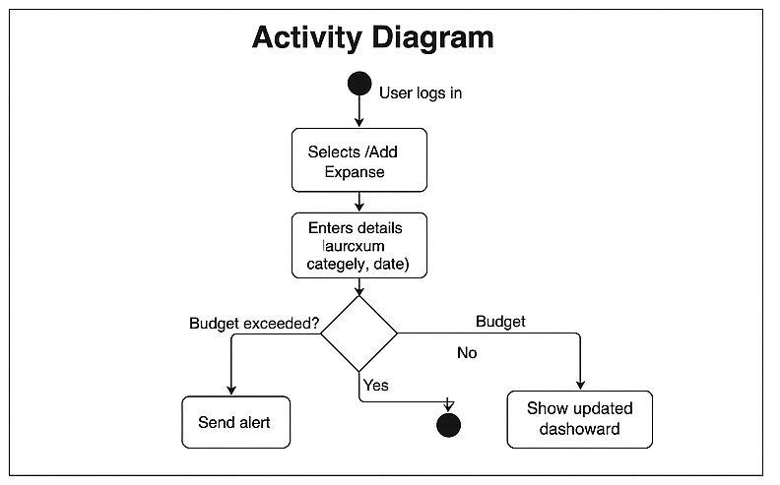

**Figure. 5.3: Activity Diagram**

The activity diagram depicts the flow from one activity to another activity. In the above activity diagram, it depicts the flow of steps involved in analyzing and interpreting the data. It includes activities like data collection,preprocessing, Exploratory Data analysis and modelling.

### 5.4 CLASS DIAGRAM:

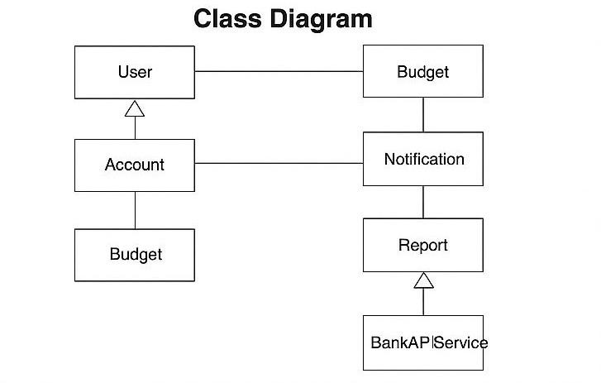

**Figure. 5.4: Class Diagram**

The class diagram represents the class, relations between the classes in the activity. Class diagram consists of classes, attributes, relations.

### 5.5 DATA FLOW DIAGRAM:

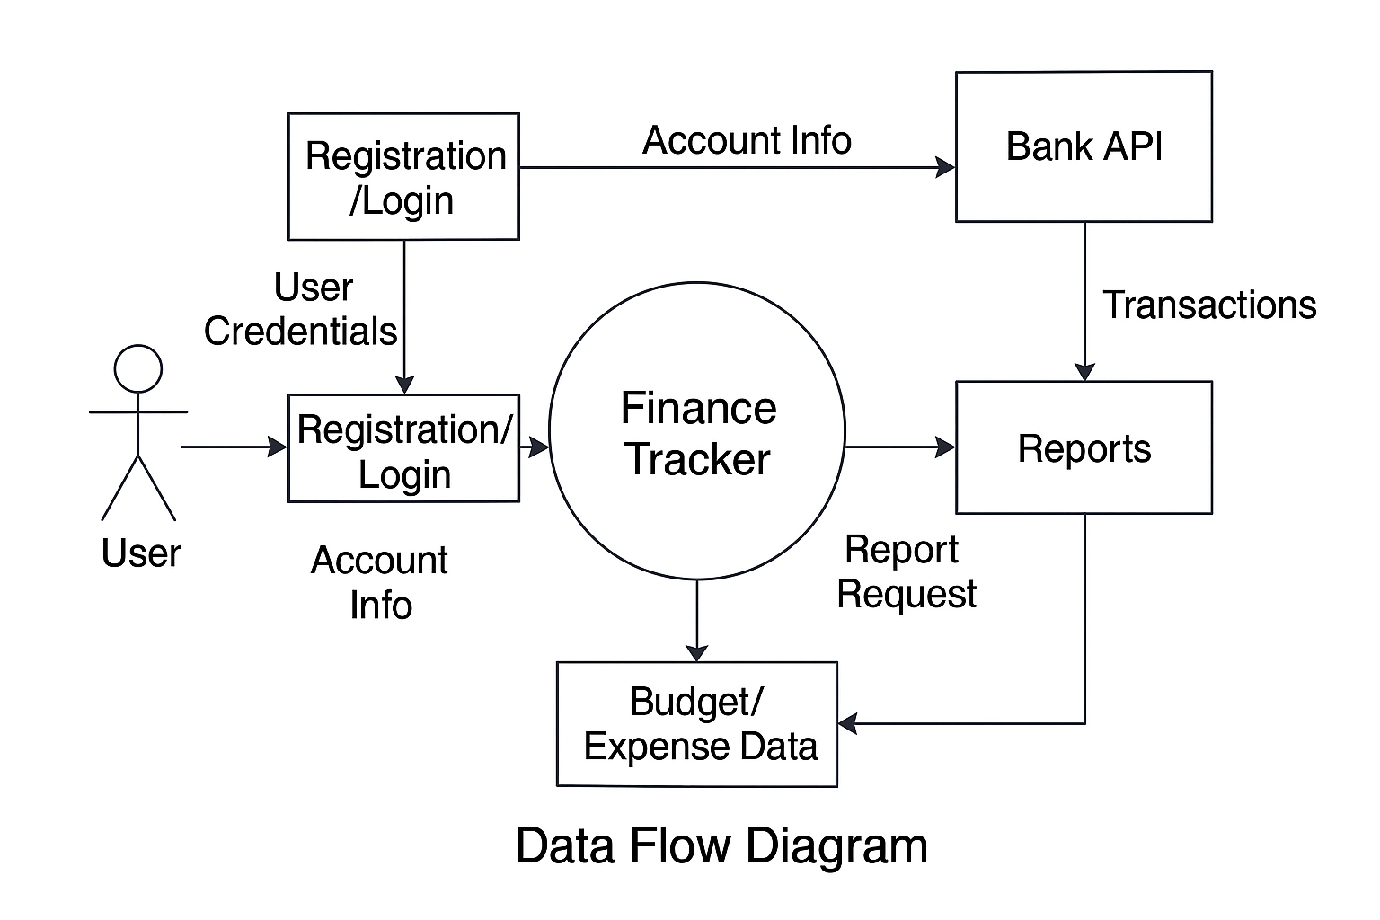

**Figure 5.5: Data Flow Diagram**

A data flow diagram shows the way information flows through a process or system. It includes data inputs and outputs, data stores, and the via sub processes the data moves through

# CHAPTER 6

# SOFTWARE IMPLEMENTATION

### Machine Learning

We probably know that computers don't communicate with each other the way that people do. Instead, computers require codes or directions. These binary codes and commands allow computers to process needed information. Every second, billions upon billions of ones and zeros are processed in order to provide you with the information you need.

So, what does that have to do with your ability to post your latest pictures online? Everything.

The methods by which computers communicate with each other through the use of markup languages and multimedia packages is known as **web technology**. In the past few decades, web technology has undergone a dramatic transition, from a few marked-up web pages to the ability to do very specific work on a network without interruption. Let's look at some examples of web technology.

### Technologies used in the application

#### PYTHON

#### Python has a rich ecosystem of libraries and frameworks specifically designed for machine learning and artificial intelligence. Some of the most popular ones include TensorFlow, PyTorch, scikit-learn, Keras, and pandas. These libraries provide pre-built functions and tools for various machine learning tasks. Python excels at data manipulation and analysis. Libraries like NumPy, pandas, and Matplotlib are essential tools for data preprocessing, exploration, and visualization, which are critical steps in any machine learning project. Python is widely adopted in the industry for machine learning applications. Many tech companies and research organizations use Python for developing cutting-edge AI and ML solutions.

### Tools Used

### 

### Colab:

### Google Colab is free to use and provides access to a GPU (Graphics Processing Unit) for faster computation. It also offers TPUs (Tensor Processing Units) for even more accelerated machine learning tasks. Colab integrates with Google Drive, allowing you to store and access your notebooks directly from your Google Drive account. It also supports importing datasets and files from your drive. Colab comes with many pre-installed Python libraries and packages commonly used in data science and machine learning, such as NumPy, pandas, Matplotlib, TensorFlow, and PyTorch.

### Learning Machine Learning is easy

### 

### Learning machine learning can be relatively easy for those with a strong foundation in mathematics and programming. With abundant online resources, tutorials, and courses, you can grasp the basics of algorithms, data preprocessing, and model building. Libraries like TensorFlow and scikit-learn simplify implementation. However, mastering ML involves continuous practice, staying updated with evolving techniques, and understanding real-world applications. It can become challenging due to complex math, hyperparameter tuning, and data nuances. So, while the initial learning curve is manageable, achieving expertise in machine learning demands dedication and ongoing learning.

### It’s Performance

### 

### It is typically assessed using various metrics, such as accuracy, precision, recall, F1 score, and others, depending on the nature of the problem. Good machine learning performance means that the model can make accurate predictions or classifications on new, unseen data. Achieving high performance often involves optimizing the model's parameters, selecting appropriate features, and handling issues like overfitting and bias.

### It is an Open Source

Technically, the point is that it is an open-source project, and they release patches often.

##### It has interfaces to a large variety of library files

PYTHON supports a large variety of library files.

.

### DATASETS(.csv files)

Datasets are collections of data organized for various purposes, such as analysis, research, or machine learning. They can contain structured or unstructured data and come in various formats, including spreadsheets, databases, text, images, and more. Datasets serve as the foundation for training and evaluating machine learning models, conducting statistical analyses, and generating insights in various domains. High-quality datasets are essential for accurate and reliable results in data-driven applications.

Datasets for the personalized finance tracker will include:

* **Transaction Data**: A collection of historical transactions including date, description, amount, and category (e.g., groceries, rent, entertainment). This data could be stored in a CSV file and used for training the machine learning model.
* **Budget Data**: User-defined budget goals for different categories (e.g., spending limit on groceries, entertainment).
* **User Profile Data**: Information about the user, including income, spending preferences, and saving goals.

### Data Analysis

### 

### Data analysis is the process of inspecting, cleaning, transforming, and interpreting data to

### extract valuable insights and make informed decisions. Here are key aspects of data analysis:

### Data Collection: The process begins with gathering relevant data from various sources, which can

### include databases, spreadsheets, sensors, surveys, and more.

### Data Cleaning: Data is often messy, containing errors, missing values, and inconsistencies. Data

### cleaning involves preprocessing to ensure data accuracy and completeness.

### Data Exploration: Analysts explore the data to understand its structure, distribution, and

### relationships. This often involves using descriptive statistics, data visualization, and exploratory

### data analysis (EDA) techniques.

### Data Transformation: Data may need to be transformed to make it suitable for analysis. This can

### include normalization, scaling, feature engineering, and creating new variables.

### Data Analysis Techniques: Analysts apply statistical, mathematical, and computational techniques

### to gain insights from the data. Common techniques include regression analysis, hypothesis testing, clustering, and machine learning.

### 6. Visualization: Data visualization plays a crucial role in data analysis. It helps convey findings and patterns through charts, graphs, and visual representations.

### 7. Interpretation: Analysts draw conclusions from the data analysis, identifying trends, patterns, and relationships. This interpretation leads to actionable insights.

### 8. Decision Making: The insights derived from data analysis are used to inform business decisions, research, policy-making, and other areas.

### Reporting: Results are often presented in reports, dashboards, or presentations to communicate

### findings to stakeholders.

### Data analysis is a fundamental process in various fields, including business, science, healthcare,

### finance, and more. It helps organizations and individuals make data-driven decisions and solve

### complex problems.

# Sample Code

# Personalized Finance Tracker using Machine learning Algorithm

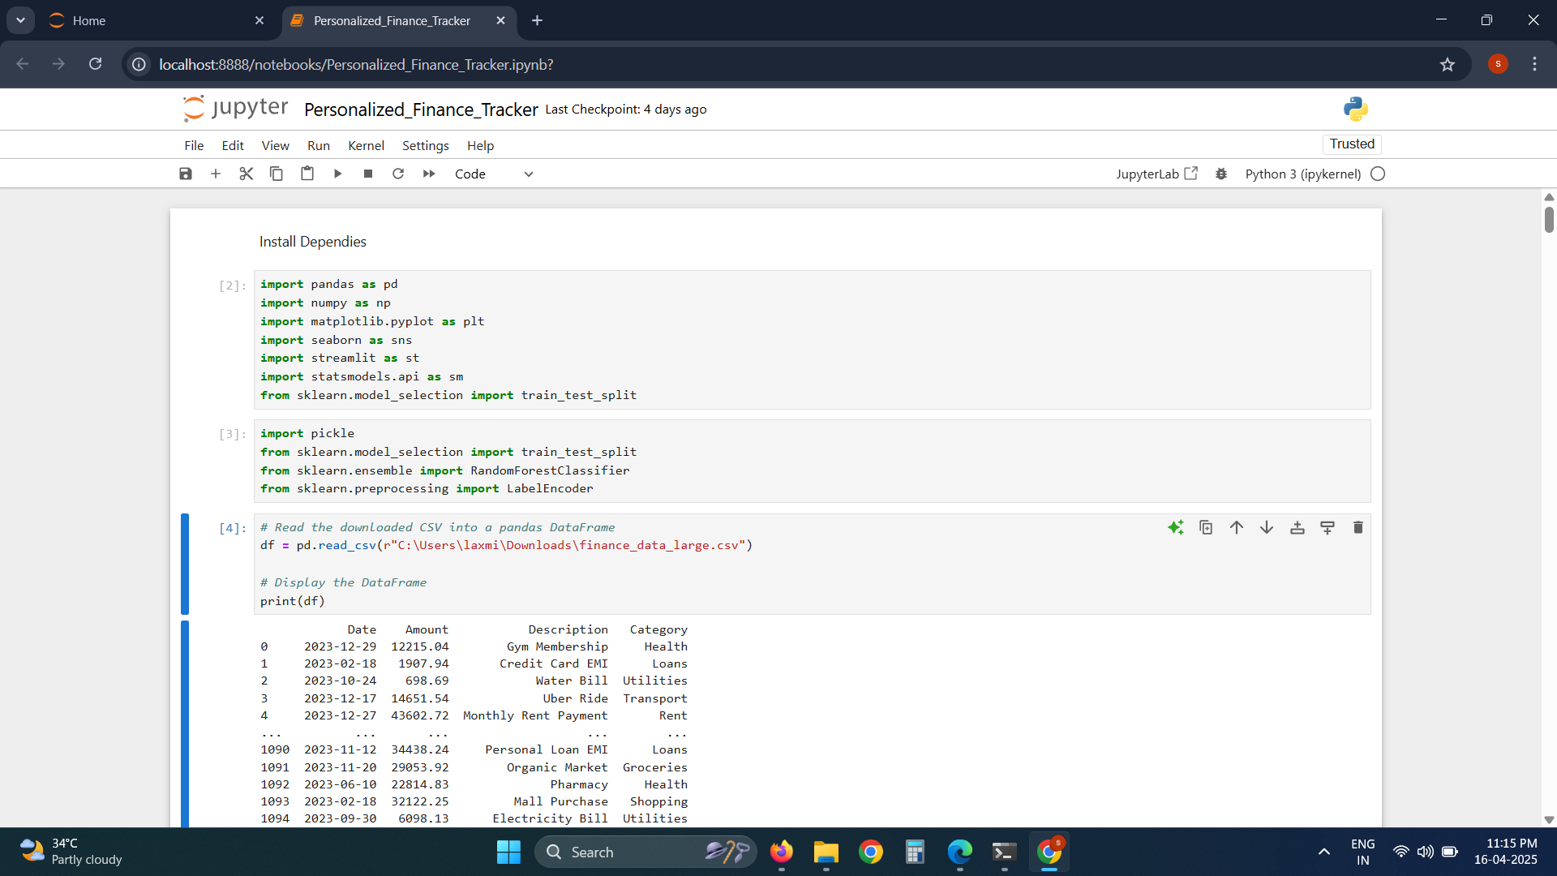

# **Figure.6.4.1:** Sample Code

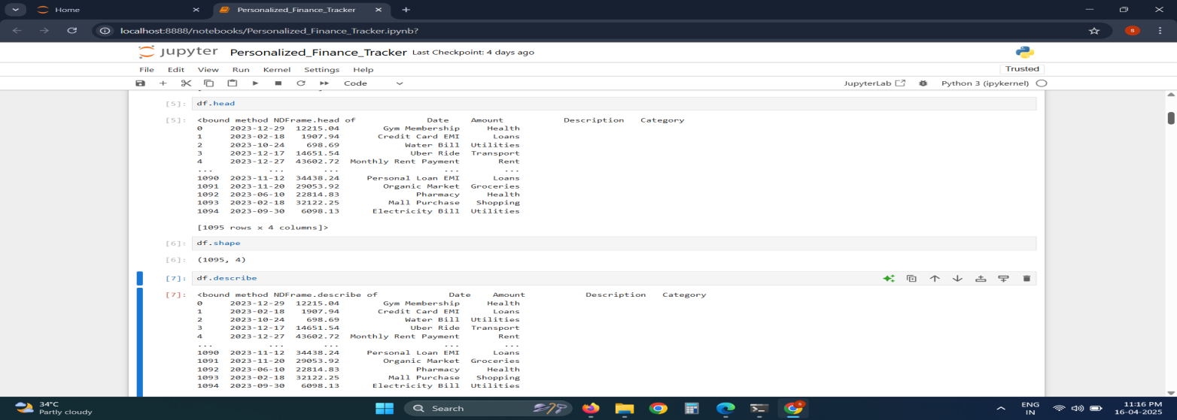

# **Figure.6.4.2:** Sample Code

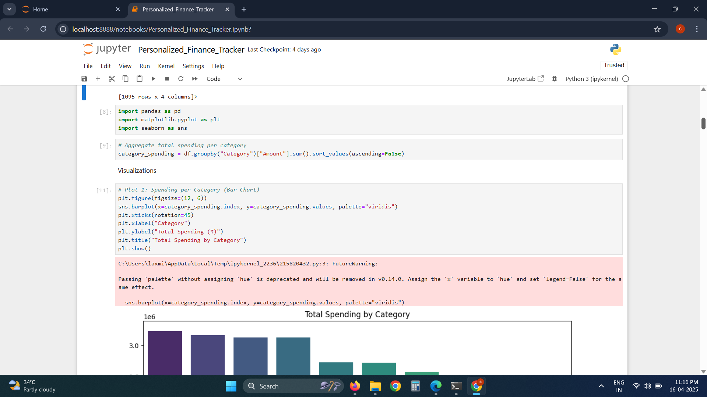

# **Figure.6.4.3:** Sample Code

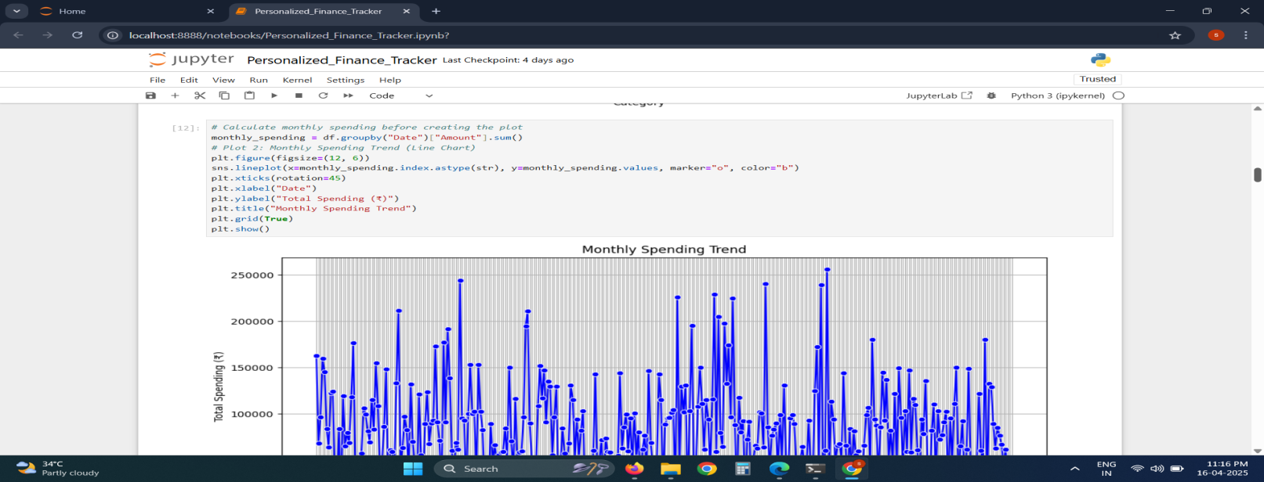

# **Figure.6.4.4:** Sample Code

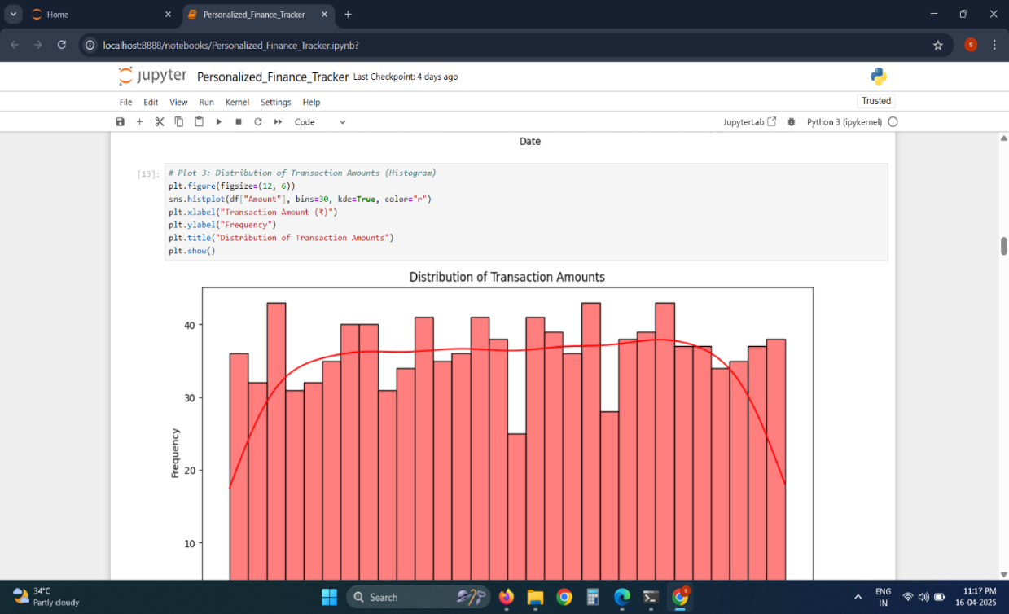

# **Figure.6.4.5:** Sample code

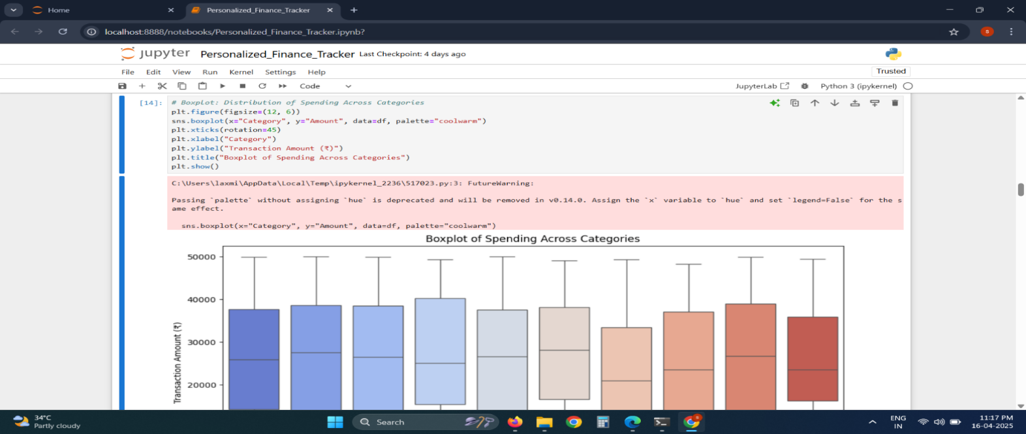

# **Figure.6.4.6:** Sample Code

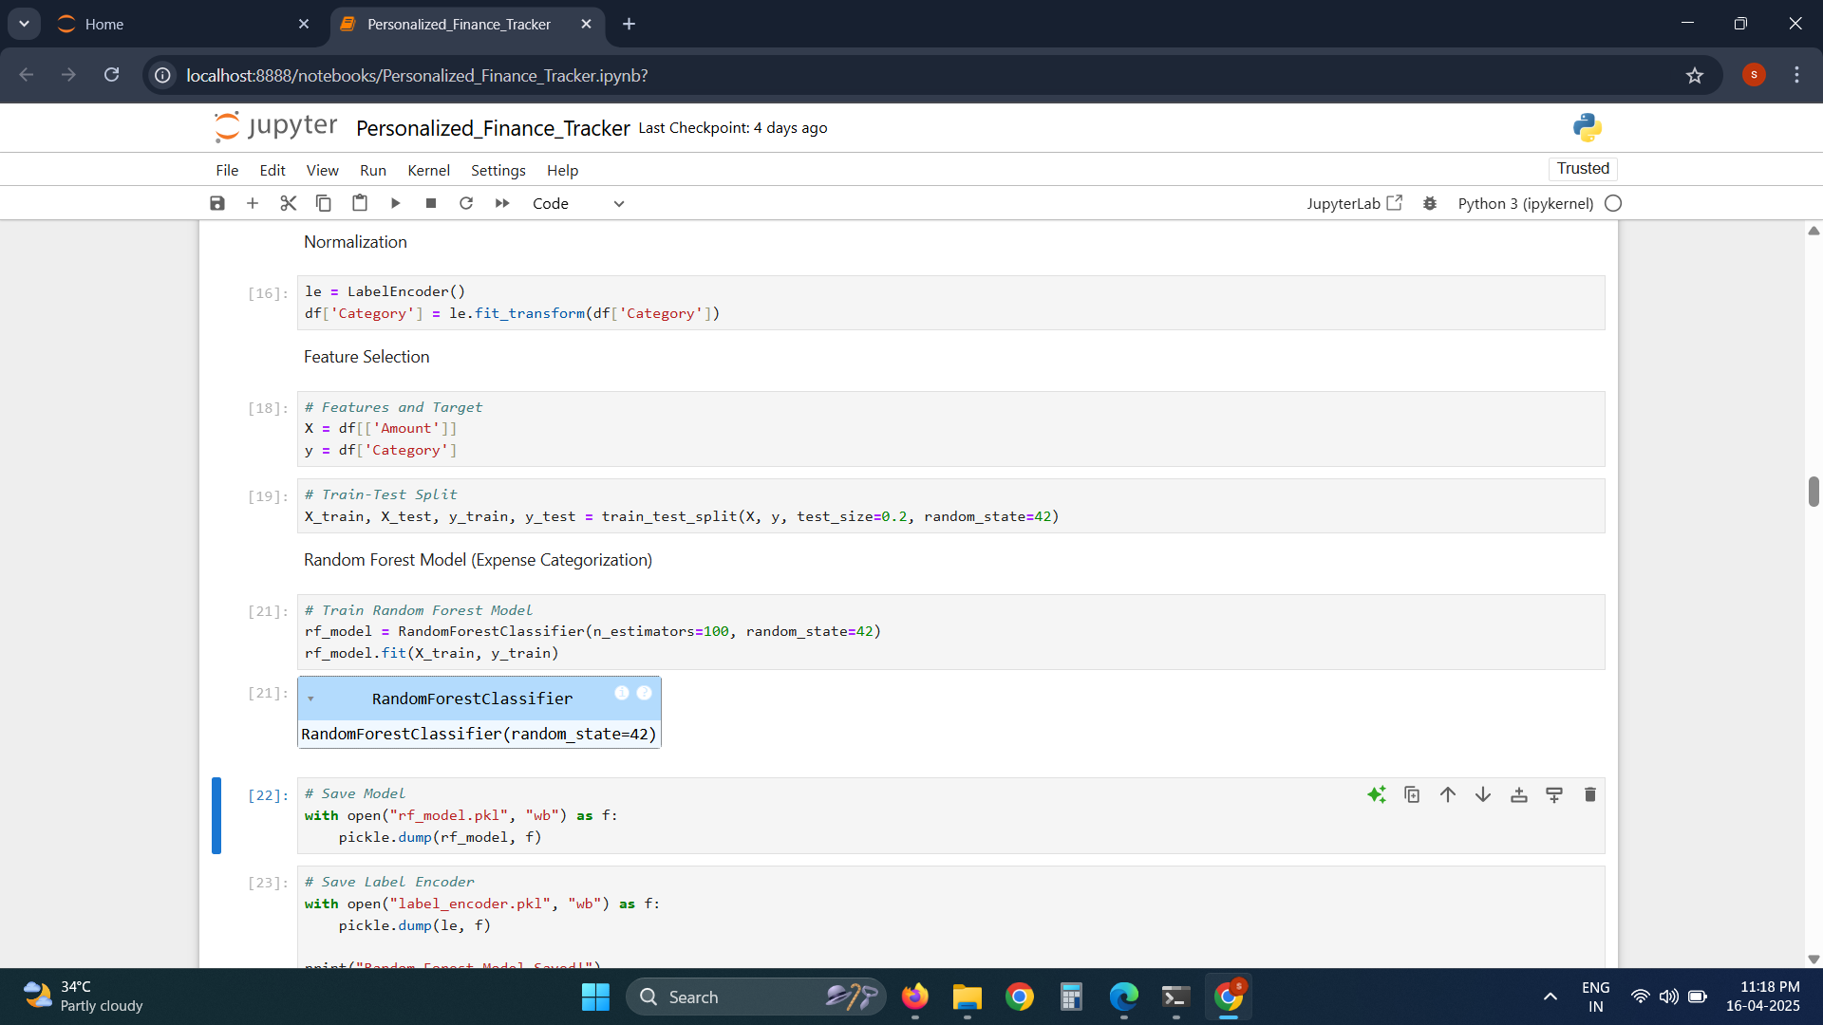

# **Figure.6.4.7:** Sample Code

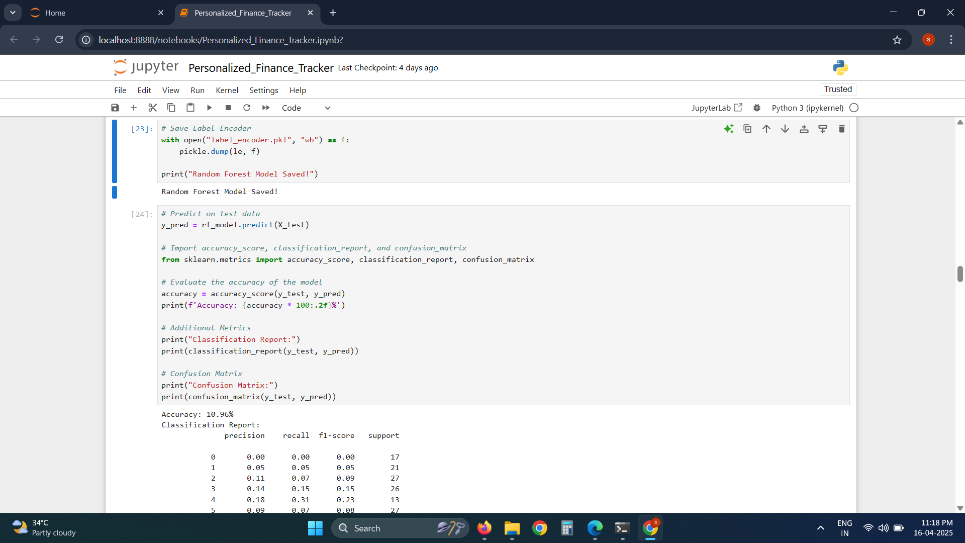

# **Figure.6.4.8:** Sample Code

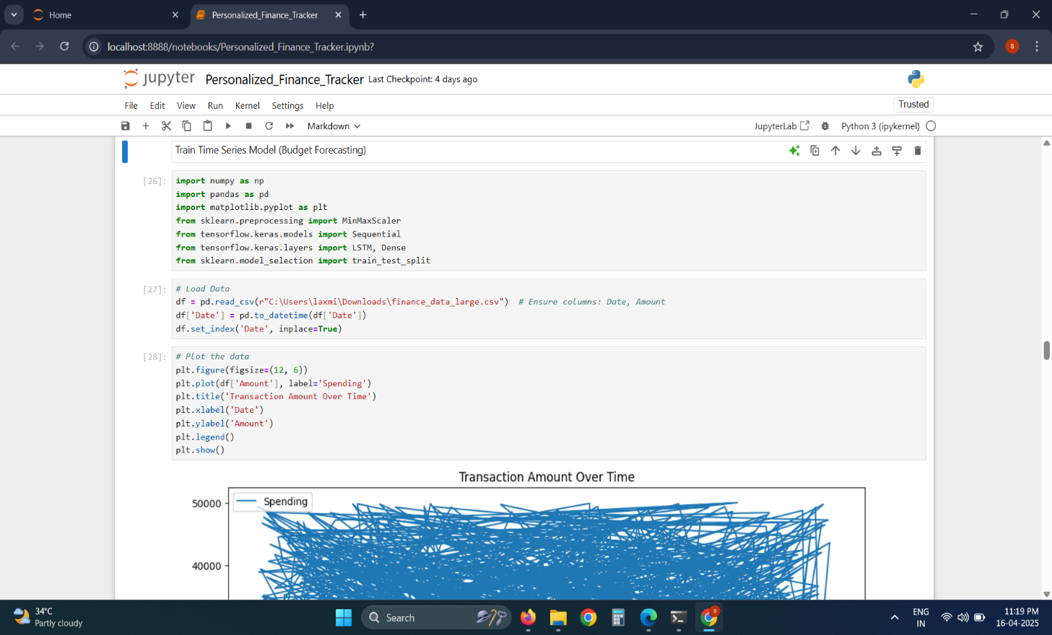

# **Figure.6.4.9:** Sample Code

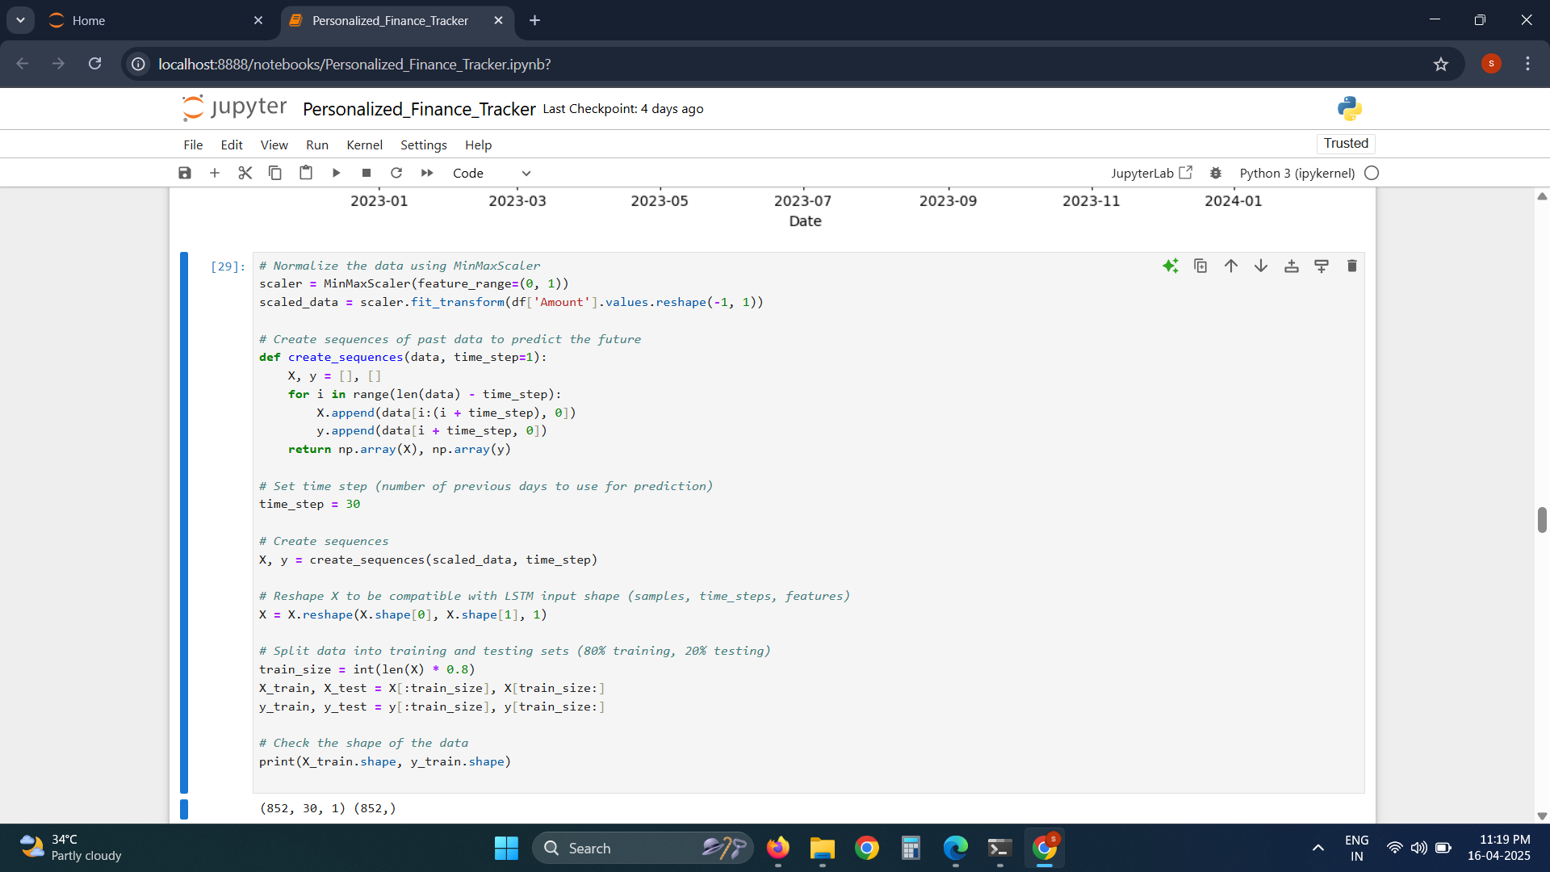

# **Figure.6.4.10:** Sample Code

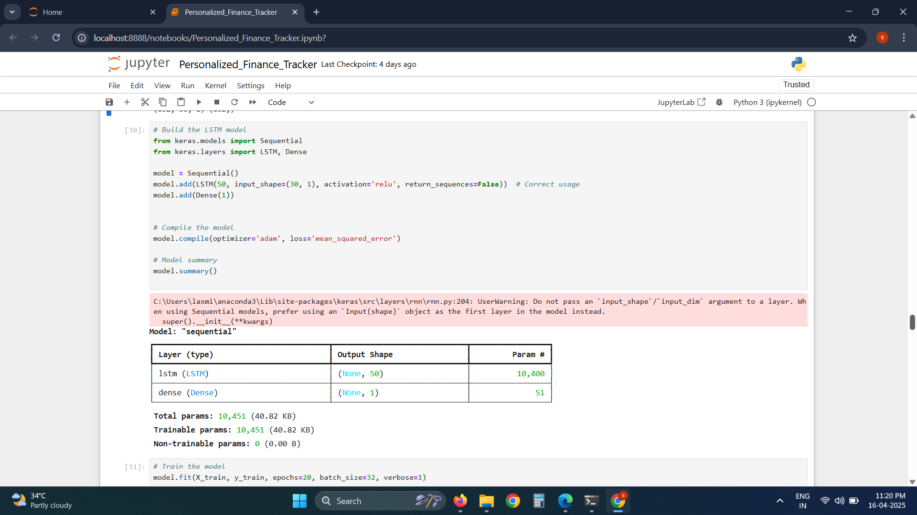

# **Figure.6.4.11:** Sample Code

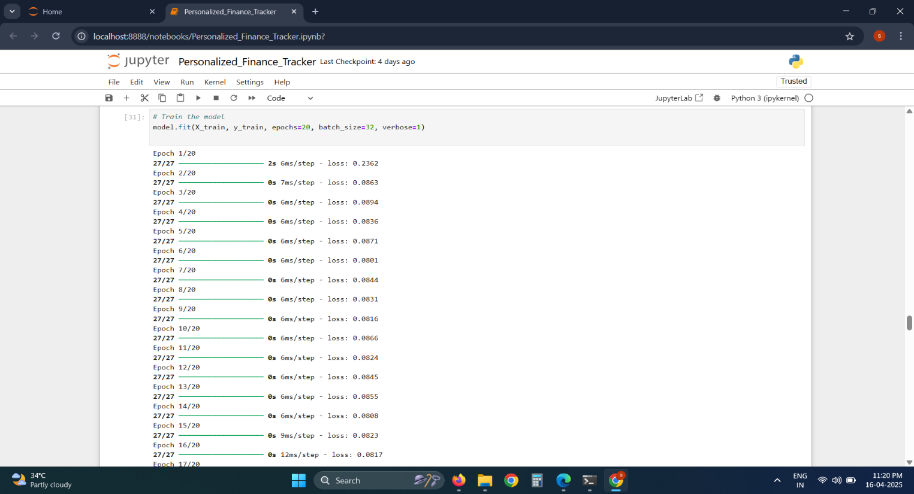

# **Figure.6.4.12:** Sample Code

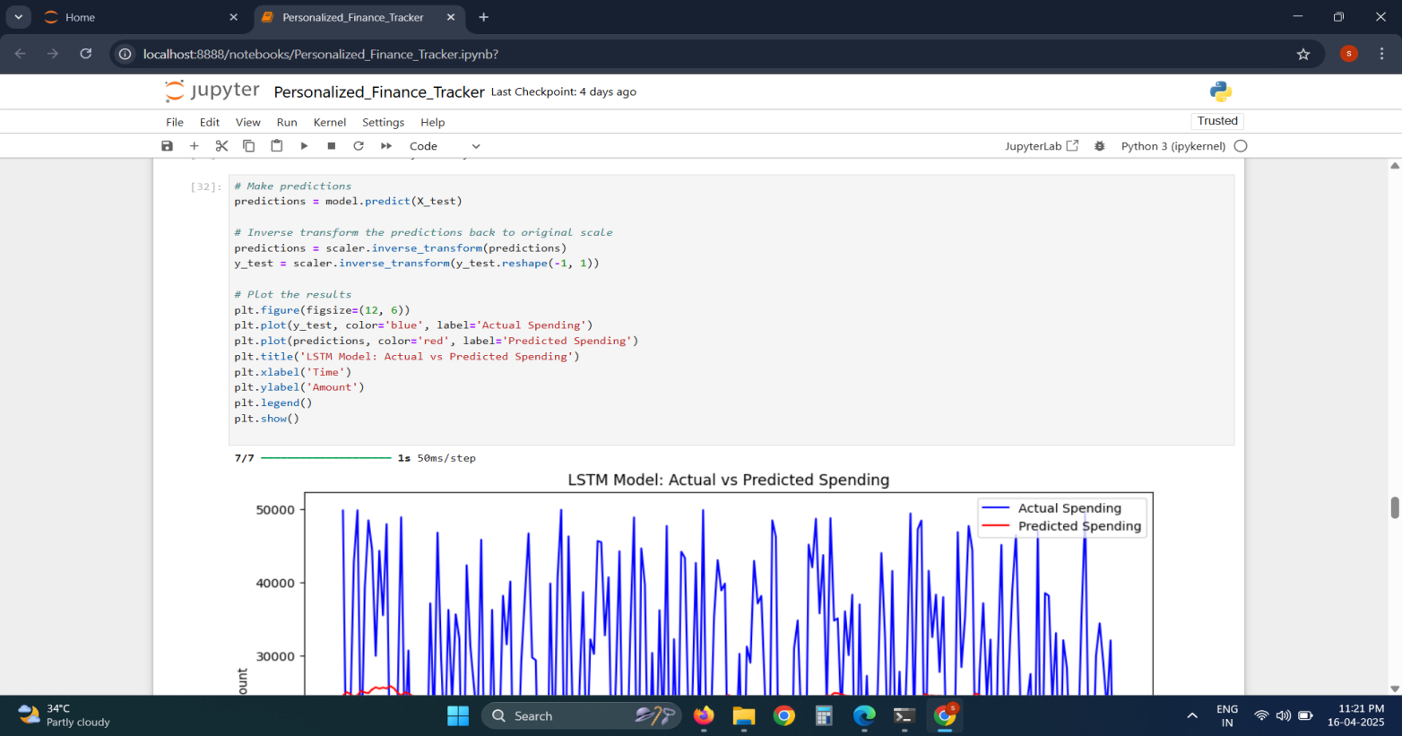

# **Figure.6.4.13:** Sample Code

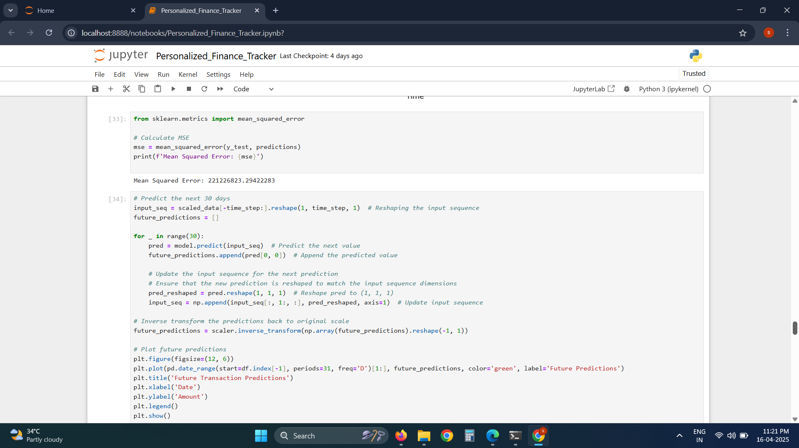

# **Figure.6.4.14:** Sample Code

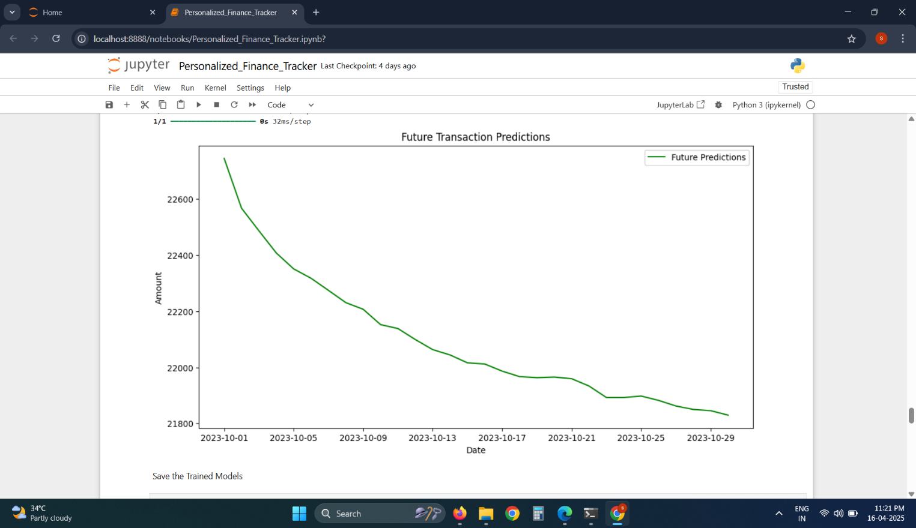

# **Figure.6.4.15:** Sample Code

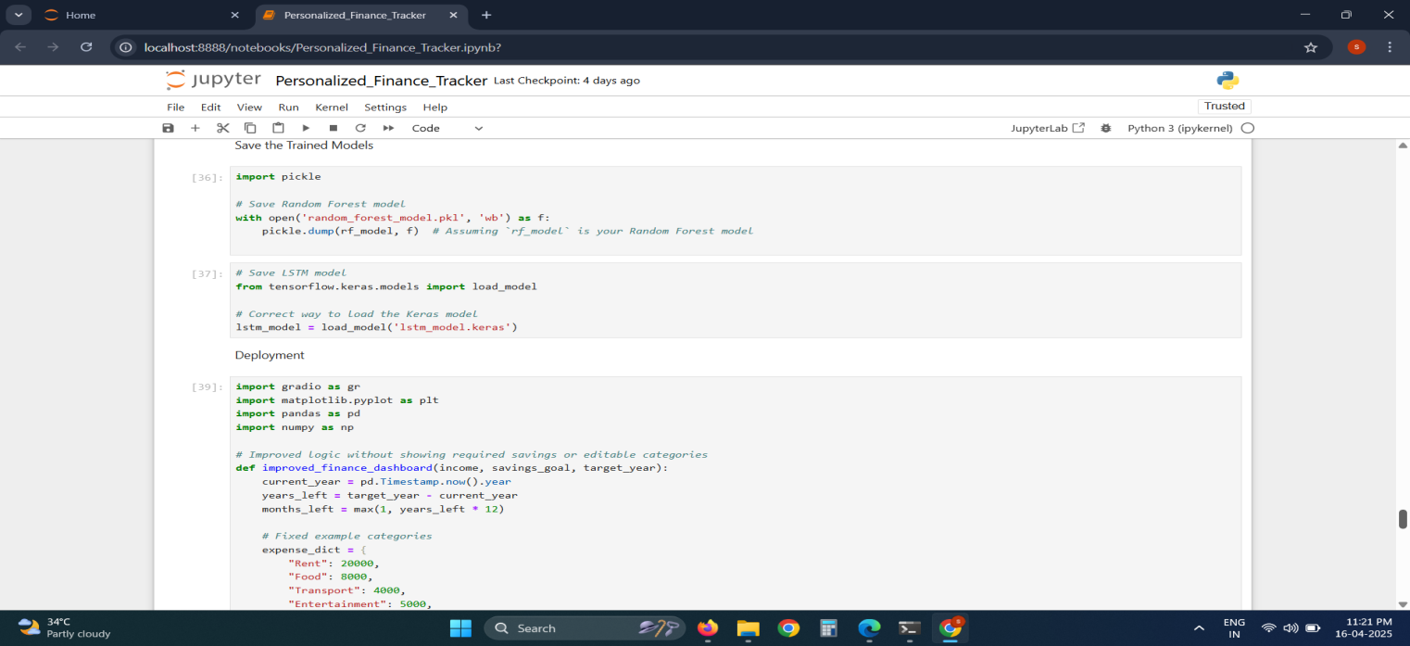

# **Figure.6.4.16:** Sample Code

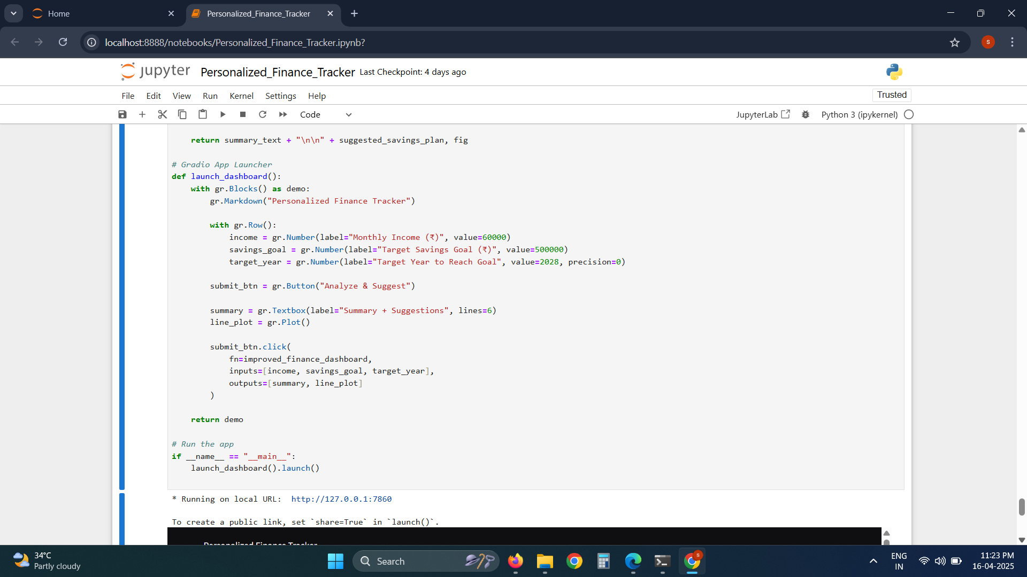

# **Figure.6.4.17:** Sample Code

**CHAPTER-7**

# SYSTEM ANALYSIS

The purpose of system analysis is to study and understand an existing or proposed system to

identify its problems, needs, and opportunities, with the goal of designing and implementing effective

and efficient solutions. It involves evaluating the current state of a system, defining requirements, and

planning improvements or new system development. System analysis helps organizations optimize

processes, enhance productivity, and meet their objectives.

### 

### 7.1 TYPES OF ANALYSIS

### 7.1.1 Exploratory Data Analysis (EDA)

Exploratory Data Analysis (EDA) is a crucial initial step in the data analysis process, aimed at gaining insights and understanding the underlying structure, patterns, and characteristics of a dataset. It involves systematically examining and visualizing the data to uncover trends, anomalies, and relationships between variables. Through EDA, analysts can identify potential issues such as missing values, outliers, or skewed distributions, which may require preprocessing or further investigation before modeling. Common techniques used in EDA include summary statistics, histograms, boxplots, scatter plots, correlation matrices, and heatmaps, among others. These visualizations help reveal patterns and dependencies within the data, aiding in feature selection, variable transformation, and model selection. Moreover, EDA enables researchers to formulate hypotheses and refine research questions based on the observed patterns, guiding subsequent analyses and interpretations. By fostering a deeper understanding of the data, EDA empowers analysts to make informed decisions, generate new insights, and derive actionable conclusions, ultimately enhancing the quality and reliability of downstream analyses and modeling efforts.

### Histogram Plot Analysis

### 

### Histogram analysis is a fundamental data visualization technique used in exploratory data analysis to understand the distribution of a single continuous variable. It represents the frequency of data points within specified ranges, known as bins, offering insights into the underlying patterns of the dataset. By plotting the data as a series of adjacent rectangles, histograms allow analysts to observe the shape, spread, and central tendency of the variable. This includes identifying skewness, modality (unimodal, bimodal), and the presence of outliers or anomalies. Histograms are particularly useful for assessing whether data follows a normal distribution, which is often an assumption in statistical modeling and machine learning. In the context of financial data, histogram analysis can reveal spending patterns, transaction frequency, and variations in user behavior, thereby aiding in informed feature engineering and model design. Overall, histograms are essential for visualizing data characteristics prior to applying advanced modeling techniques.

### Output image

### 

### Fig 7.1.2 Histogram Plot Analysis

### Box Plot Analysis

Boxplot analysis is a graphical method used to summarize and compare the distribution of a continuous variable across different groups or categories. The boxplot displays the distribution of data through five key summary statistics: the minimum and maximum values (whiskers), the lower and upper quartiles (box boundaries), and the median (line inside the box). Additionally, outliers, which are data points that lie significantly outside the range of the rest of the data, are often represented as individual points beyond the whiskers. Boxplots provide valuable insights into the central tendency, spread, and skewness of the data within each group or category, making them useful for detecting differences, trends, or patterns. By visually comparing the boxplots of multiple groups, analysts can identify variations in the distribution of the variable, assess the presence of outliers, and infer potential relationships or associations between the variable and the groups under investigation. Boxplots are particularly beneficial when dealing with large datasets or when exploring the distributional properties of variables across different conditions, treatments, or demographics. However, it's important to interpret boxplots in conjunction with other statistical analyses and domain knowledge to draw accurate conclusions about the data. Overall, boxplot analysis serves as a valuable exploratory tool in data analysis, facilitating the identification of trends and patterns that can inform further investigation or decision-making processes.

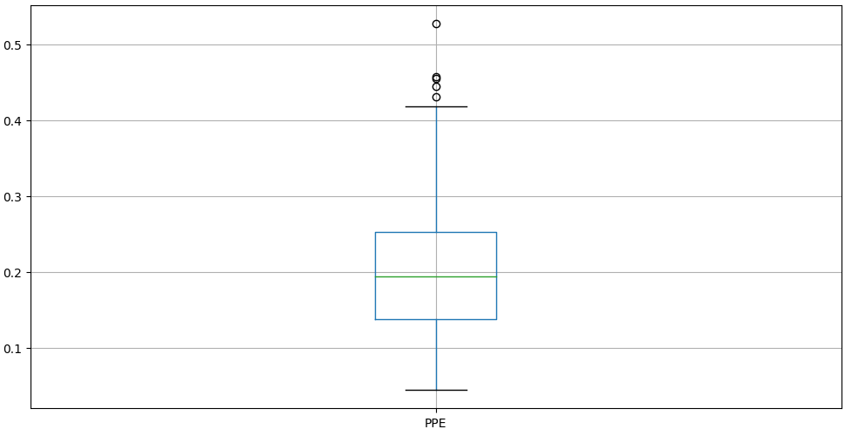

Fig 7.1.3 Box Plot Analysis

### Modelling

Modeling in machine learning (ML) involves the process of training algorithms on datasets to make predictions or decisions without being explicitly programmed. This process typically begins with data preprocessing, where raw data is cleaned, transformed, and prepared for analysis. Next, a suitable ML algorithm is selected based on the nature of the problem, data characteristics, and desired outcomes. The chosen algorithm is then trained on a portion of the dataset, called the training set, where it learns the patterns and relationships within the data. During training, the algorithm adjusts its internal parameters iteratively to minimize the difference between predicted and actual outcomes. Once trained, the model is evaluated using a separate portion of the dataset, called the test set, to assess its performance and generalization ability. This evaluation helps to identify potential issues such as overfitting or underfitting, which can be addressed through techniques like regularization or hyperparameter tuning. Finally, the trained model can be deployed to make predictions on new, unseen data, thereby enabling automation and decision-making in various domains, from finance and healthcare to marketing and beyond. Overall, modeling in ML empowers organizations to extract valuable insights, optimize processes, and make data-driven decisions to achieve their objectives.

**7.2.2 Random Forest**

Random forest is a powerful ensemble learning technique in machine learning, commonly used for both classification and regression tasks. It operates by constructing a multitude of decision trees during training, where each tree is trained on a random subset of the dataset and a random subset of the features. This randomness helps to decorrelate the individual trees, leading to a diverse set of models. During prediction, the random forest aggregates the predictions of all the individual trees to make a final prediction, either through voting (in classification) or averaging (in regression). One of the key advantages of random forests is their ability to handle high-dimensional datasets with large numbers of features while mitigating overfitting, thanks to the randomness introduced during both training and prediction. Additionally, random forests provide insights into feature importance, enabling users to identify the most influential features in predicting the target variable. Moreover, they are robust to noisy data and outliers, making them suitable for a wide range of real-world applications. Despite their versatility and effectiveness, tuning the hyperparameters of a random forest, such as the number of trees and maximum depth, is essential for optimizing performance and preventing underfitting or overfitting. Overall, random forest models are widely adopted in various domains, including finance, healthcare, ecology, and bioinformatics, due to their robustness, scalability, and ability to deliver high-quality predictions.

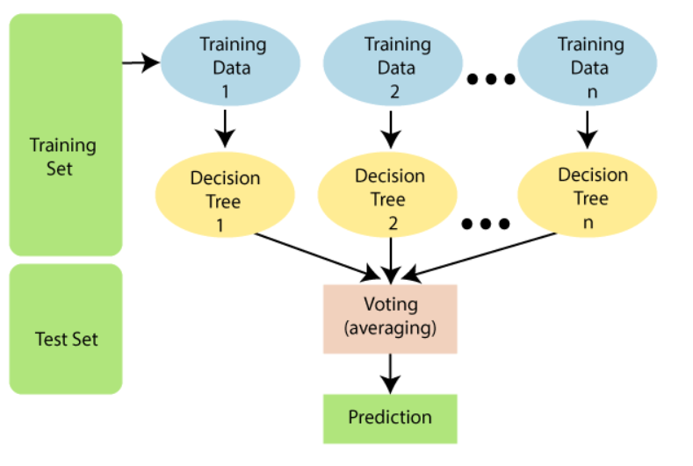

### Fig 7.2.2 Flow chart for Random forest

**7.2.3 LSTM**

long Short-Term Memory (LSTM) is a specialized type of recurrent neural network (RNN) designed to model and learn long-term dependencies in sequential data. Unlike traditional RNNs, LSTMs effectively address the vanishing gradient problem by incorporating memory cells and gating mechanisms—input, forget, and output gates—that regulate the flow of information. This architecture enables LSTM networks to retain relevant past information over extended periods, making them highly suitable for time-series forecasting, natural language processing, and sequential pattern recognition.

In the context of financial tracking systems, LSTM models can analyze and predict future financial trends based on historical transaction sequences. By learning temporal dependencies, LSTMs enhance forecasting accuracy for income and expenditure trends, alerting users to potential anomalies or future financial risks. Their capability to adapt to sequential patterns makes LSTM a powerful tool for creating personalized financial insights that evolve with user behavior.

### 

# CHAPTER-8

**OUTPUT SCREENS**

### 8 .1 OUTPUT:

### 

### 

### 

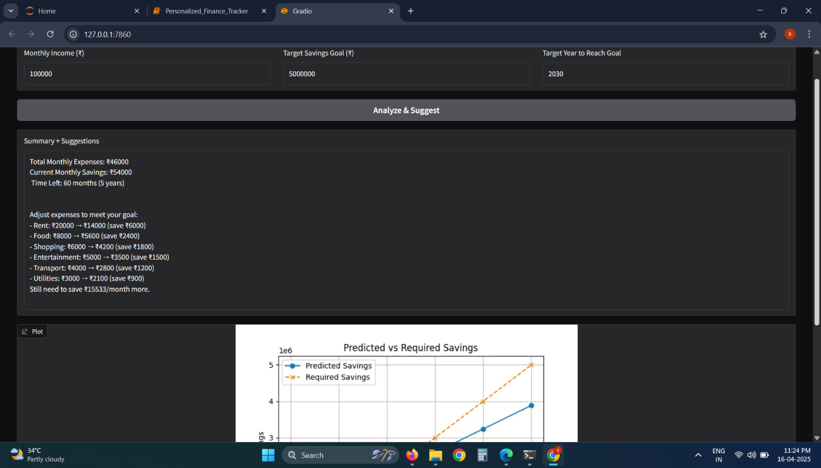

Fig 8 output

### 

### UPLOADING THE DATASET

### Uploading a dataset involves transferring a collection of data from a local storage location to a digital platform or system. This process is commonly performed in data analysis, machine learning, and other data-driven tasks. Users typically upload datasets to cloud-based platforms, such as Google Colab, Kaggle, or cloud storage services like Google Drive or Dropbox. Uploading datasets allows users to access and work with the data remotely, enabling collaboration, analysis, and model building from anywhere with an internet connection. Additionally, platforms often provide tools for importing datasets directly from local storage or external sources, streamlining the process and facilitating seamless integration into analysis workflows. Overall, uploading datasets is a fundamental step in data-driven tasks, enabling users to leverage data for insights, decision-making, and innovation.

### 8.2 CLEANING THE DATASET

### 

### Cleaning data for finance data using machine learning involves several steps to ensure the dataset is suitable for training a model.

### 1. Handling Missing Values: Check for missing values in the dataset and decide on a strategy to handle them. This could involve imputation techniques such as mean, median, or mode imputation, or more advanced methods like predictive modeling to estimate missing values.

### 2. Removing Duplicates: Identify and remove any duplicate rows in the dataset to prevent bias in the model training process.

### 3. Dealing with Outliers: Detect and address outliers in the data that may adversely affect model performance. This can involve techniques such as Z-score, IQR (Interquartile Range), or visualization methods.

### 4. Feature Engineering: Create new features or modify existing ones to enhance the predictive power of the model. This might involve transformations, scaling, or combining features to better capture patterns related to finance data.

### 5. Handling Categorical Data: If the dataset contains categorical variables, encode them into numerical values using techniques such as one-hot encoding or label encoding.

### 6. Normalization and Scaling: Normalize or scale the numerical features to ensure they have a similar scale, which can improve the performance of certain machine learning algorithms.

### 7. Splitting Data: Split the dataset into training and testing sets to evaluate the performance of the model on unseen data.

### 8. Addressing Class Imbalance: If the dataset used in the personalized finance tracker shows an imbalance between different spending categories (e.g., significantly more entries under groceries compared to investments or entertainment), it is essential to address this skew. Techniques such as oversampling underrepresented categories, under sampling dominant ones, or generating synthetic data entries can help create a more balanced dataset.

### By thoroughly cleaning and preparing the dataset, the personalized finance tracker can provide more accurate insights and recommendations based on user spending patterns. Moreover, it's important to validate the performance of analytical models using appropriate evaluation metrics to ensure the tracker’s predictions and suggestions remain reliable and relevant across diverse financial behaviors.

### RUN ON MACHINE LEARNING ALGORITHMS :

### 

### In the context of building a personalized finance tracker using machine learning algorithms:

### Data Preprocessing: Begin by cleaning, normalizing, and encoding financial transaction data, including user demographics, spending patterns, income sources, and budgeting categories. This ensures that the data is structured and consistent for analysis.

### Feature Selection/Engineering: Identify or engineer features that are most indicative of financial behavior, such as monthly savings rate, discretionary vs. essential spending, credit utilization, or seasonal trends. This step may require domain expertise and statistical methods to uncover impactful variables.

### Model Selection and Training: Select suitable machine learning algorithms such as decision trees, random forests, K-nearest neighbors, or deep learning models depending on the task—be it classification (e.g., identifying spending anomalies) or regression (e.g., predicting future expenses). Train the chosen models using the processed financial data.

### Model Evaluation: Assess the model’s performance using metrics such as accuracy, precision, recall, F1-score, and confusion matrix. This evaluation ensures the model performs reliably on new, unseen financial data and aligns with user goals.

### Interpretation and Analysis: Analyze the trained models to understand the contribution of various features to financial predictions. Extract insights into spending habits, income dependencies, or financial risks to support personalized financial planning.

### Visualization: Present results through intuitive visuals such as bar charts, pie charts, trend lines, and heatmaps. These help users easily interpret their financial status and gain actionable insights for better decision-making.

### 

### ANALYSIS :

### In analyzing data for a personalized finance tracker, machine learning techniques can be employed to uncover spending patterns, user behavior, and financial trends. Clustering algorithms can be used to group users based on spending habits or income brackets, while heat maps and time-series visualizations can reveal seasonal trends and peak expenditure periods. Statistical methods help identify correlations between financial decisions and user demographics or goals. These insights enable personalized financial recommendations, better budget planning, and informed decision-making. The analysis ultimately supports the development of a system that promotes financial awareness, planning, and improved money management for users.

### BAR-GRAPH ANALYSIS :

### 

### Bar graph analysis involves using bar graphs to visualize and analyze performance factors across different categories or groups. This method is particularly useful for comparing the relative performance of multiple factors or entities.

### In the context of analyzing performance factors, data analysts often collect and organize performance metrics or indicators for various entities, such as companies, products, or individuals. These performance factors could include financial metrics (e.g., revenue, profit), operational metrics (e.g., efficiency, productivity), or any other relevant performance indicators.

### Once the data is collected and organized, analysts use bar graphs to visually represent the performance of each factor across different categories or groups. Each bar in the graph represents the value of a specific performance factor for a particular category or group, with the height of the bar indicating the magnitude of the performance metric.

### By examining the bar graph, analysts can quickly identify patterns, trends, and differences in performance across different categories or groups. They can also compare the relative performance of different factors within each category, helping to identify strengths, weaknesses, and areas for improvement.

### Overall, bar graph analysis provides a clear and intuitive way to understand and communicate performance data, making it a valuable tool for decision-making and performance management in various fields such as business, finance, healthcare, and education.

### Factors of Performance Evaluation

### 

### Accuracy:

### In machine learning, accuracy is a commonly used metric to evaluate the performance of a model, representing the proportion of correctly predicted outcomes over the total number of predictions. Higher accuracy indicates better predictive capability, making it a fundamental measure in assessing model effectiveness. However, accuracy alone may not provide a complete picture of model performance, especially in the presence of imbalanced datasets or when different types of errors carry varying degrees of importance.

### F-1 Score:

### The F1 score is a metric commonly used in machine learning to assess the balance between precision and recall of a classification model. It provides a single value that considers both false positives and false negatives, making it useful for evaluating model performance in imbalanced datasets. A higher F1 score indicates better overall performance of the model in terms of both precision and recall.

### Recall:

### In machine learning, recall, also known as sensitivity or true positive rate, measures the proportion of actual positive instances that were correctly identified by the model. It is calculated as the ratio of true positives to the sum of true positives and false negatives. A higher recall indicates that the model is better at capturing all positive instances, minimizing false negatives, which is crucial in scenarios where missing positive cases is costly or harmful.

### Precision:

### In machine learning, precision is a metric used to measure the proportion of correctly predicted positive instances out of all instances predicted as positive. It helps evaluate the model's ability to avoid false positives, making it particularly useful in scenarios where false positives are costly or undesirable.

### 

### Fig 8.5 Performance Evaluation

### Requirement DataSet :

### 

### The requirement for personalized finance tracker project, the dataset should be comprehensive and cover several key areas to enable accurate tracking and analysis. It should include user profile information such as unique identifiers, name, age, gender, occupation, income range, and location. These details will help tailor financial advice and budgeting strategies for each user. Income data is crucial for understanding the user’s financial capacity, including salary, other income sources, and income frequency. Additionally, a detailed record of the user’s expenses both fixed and variable should be maintained, including recurring costs like rent and utilities, as well as discretionary spending such as groceries and entertainment. The dataset should also track debt payments, savings contributions, and investments across different assets like stocks, mutual funds, cryptocurrencies, and real estate. Financial goals, both short- and long-term, must be captured to guide users in their savings journey. Transaction data is another critical component, where each transaction is categorized by type, amount, date, and merchant details. The dataset should also incorporate credit score data to provide insights into the user’s credit health, as well as tax-related information like tax brackets and deductions. Additionally, setting up alerts and reminders for bill payments or goal achievements will keep users on track. Lastly, ensuring data security and privacy is essential, using encryption and access controls to safeguard sensitive financial details. This structured dataset will provide the foundation for delivering personalized financial recommendations and insights for your users.

### Financedatalarge.csv file :

### The financedatalarge.csv file serves as the primary dataset utilized for training and evaluating machine learning models in the personalized finance tracker system. This CSV (Comma-Separated Values) file comprises structured financial data collected from diverse sources, encompassing a wide range of user financial behaviors and transactions. The dataset includes features such as income, expenses, transaction categories, payment methods, time stamps, and user-specific attributes.

### 

# CHAPTER:9

# CONCLUSION

The Personalized Finance Tracker system demonstrates a robust approach to financial management, utilizing sophisticated data analysis techniques and machine learning algorithms to provide tailored solutions for individual users. By incorporating methods such as Exploratory Data Analysis (EDA), the system extracts meaningful insights from user data, revealing spending behaviors, trends, and areas for financial optimization. This analysis empowers users to make informed decisions and gain a deeper understanding of their financial health.

The integration of machine learning models such as Decision Trees, Random Forests, K-Nearest Neighbors (KNN), and AdaBoost significantly enhances the system's ability to process and predict user financial data. These models facilitate:

* Accurate categorization of transactions.
* Effective prediction of future spending patterns.
* Detection of anomalies and outliers that may signal potential issues or opportunities for savings.
* Continuous model improvement through dynamic learning techniques.

The system’s use of ensemble methods, such as Random Forests and AdaBoost, not only improves the accuracy of predictions but also ensures that the system remains resilient against overfitting and can handle diverse, high-dimensional datasets. Meanwhile, the simplicity and interpretability of KNN make it a valuable tool for personalized user recommendations and insights.

In conclusion, the Personalized Finance Tracker system represents a comprehensive, user-centric solution to personal finance management, combining advanced data analysis with machine learning to provide actionable insights and foster improved financial decision-making. As the system evolves, continued enhancements in data preprocessing, algorithm optimization, and user experience will ensure that it remains a state-of-the-art tool for financial empowerment, adapting to the growing complexity of user data and financial behaviors.

**CHAPTER-10**

**FUTURE ENHANCEMENT**

The Personalized Finance Tracker has significant potential for future advancements, primarily through the integration of real-time financial data from banking APIs and financial institutions. This would enable users to automatically track transactions, update budgets, and receive immediate insights into their financial health, reducing manual input and enhancing accuracy.

To further refine its predictive capabilities, the system could incorporate advanced machine learning algorithms such as deep learning and time series forecasting. These enhancements would offer more accurate predictions about spending patterns, savings trends, and investment opportunities.

User experience could be enhanced by incorporating AI-driven personalization. By leveraging machine learning to analyze user behavior, the system could provide tailored financial advice and automated goal-setting. Additionally, introducing natural language processing (NLP) would allow users to interact with the system more intuitively.

In order to increase its global appeal, the system could add support for multi-currency and multi-language functionalities, making it accessible to users worldwide. Furthermore, ensuring stronger data security through biometric authentication, two-factor authentication (2FA), and encryption would ensure user confidence.

Gamification elements could also be added to encourage regular engagement, especially for younger users, by introducing rewards and financial challenges. Moreover, integration with other financial tools such as Mint or QuickBooks would provide users with a consolidated view of their finances, streamlining financial management.

Finally, incorporating blockchain technology would enhance transaction transparency and security, while smart contracts could automate specific financial tasks, providing users with a more seamless and secure experience.

In conclusion, future enhancements focused on AI, machine learning, security, and global accessibility would significantly elevate the Personalized Finance Tracker, positioning it as a cutting-edge tool for efficient and secure financial management.

# CHAPTER 11

### REFERENCES

[1] A. Géron. Hands-On Machine Learning with Scikit-Learn, Keras, and TensorFlow, 2nd ed., O'Reilly Media, 2019.

[2] S. Raschka and V. Mirjalili. Python Machine Learning, 3rd ed., Packt Publishing, 2019.

[3] J. Han, M. Kamber, J. Pei. Data Mining: Concepts and Techniques, 3rd ed., Morgan Kaufmann Publishers, 2011.

[4] F. Pedregosa et al., "Scikit-learn: Machine Learning in Python", Journal of Machine Learning Research, vol. 12, pp. 2825–2830, 2011.

[5] R. D. Peng. Exploratory Data Analysis with R, Lulu.com, April 2016.

[6] L. Breiman, "Random Forests", Machine Learning, vol. 45, no. 1, pp. 5–32, 2001.

[7] Y. Freund and R. E. Schapire, "A Decision-Theoretic Generalization of On-Line Learning and an Application to Boosting", Journal of Computer and System Sciences, vol. 55, no. 1, pp. 119–139, 1997.

[8] McKinney, W. Python for Data Analysis, 2nd ed., O’Reilly Media, 2017.

[9] Patel, P., Sivaiah, B. and Patel, R., 2022. "Approaches for finding Optimal Number of Clusters using K-Means and Agglomerative Hierarchical Clustering Techniques", in 2022 Int. Conf. on Intelligent Controller and Computing for Smart Power (ICICCSP), pp. 1-6, IEEE.

[10] Sumithra, M., Shruthi, S., Ram, S., Swathi, S., Deepika, T., "MRI image classification of brain tumor using deep neural network and deployment using web framework", Advances in Parallel Computing, vol. 38, pp. 614–617, 2021.

[11] Google Developers, "Google Colaboratory Documentation", Retrieved from: [https://colab.research.google.com](https://colab.research.google.com/)

[12] Python Software Foundation, "The Python Language Reference", Retrieved from: <https://www.python.org/doc/>

[13] Kaggle Datasets, "Finance Datasets", Retrieved from: <https://www.kaggle.com/datasets>